2nd Nine Weeks Biology Exam Study Guide
Semester I
Name: ____________________________________ Date: _____________________ Block: _____________
- Experimental Design SOL BIO. 1abcefhijlm.

- Fill in the following chart about the experimental design.

Possible Hypothesis | Independent Variable | Dependent Variable | Control | Constant
If I study then I will pass the semester exam.
If you break up with your bae then you will be sad.
If you add sunlight then the plant will grow faster.

- Fill in the following chart about the experimental design.

Problem | Independent Variable | Dependent Variable | Possible Hypothesis
Will the use of antibiotics affect bacteria growth?
Will loud music affect the height of corn plants?
Will the amount of sunlight affect the amount of oxygen produced in a plant?

- The best places to get new and accurate data and information about science are?

- Label the parts of the microscope below and describe their uses.
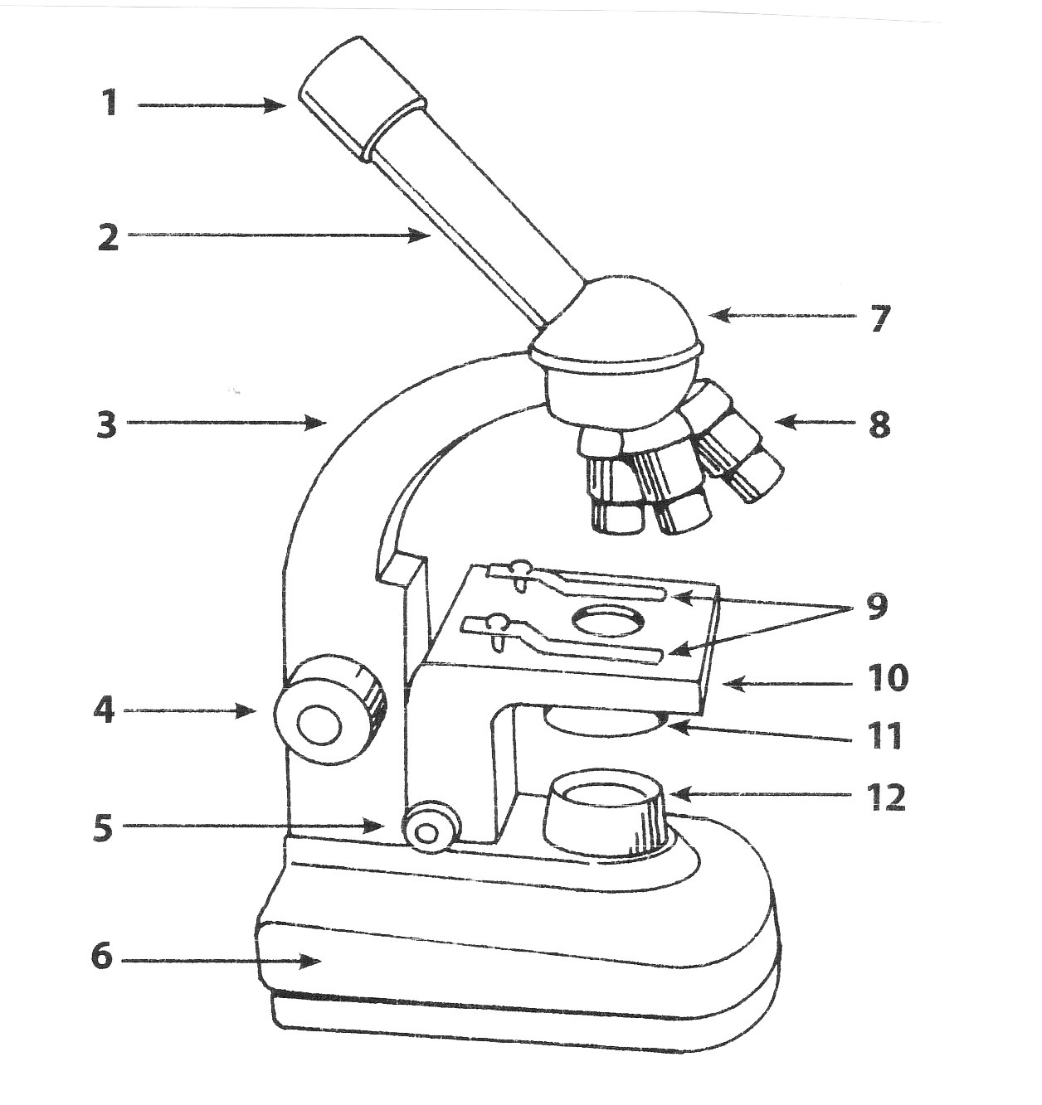

PART | FUNCTION (What does it do?)
1.
2.
3
4.
5.
6.
7.
8.
9.
10.
11.
12.

- Cell Division SOL Bio 3e, 5a,f.
- Fill in the following diagram on mitosis.
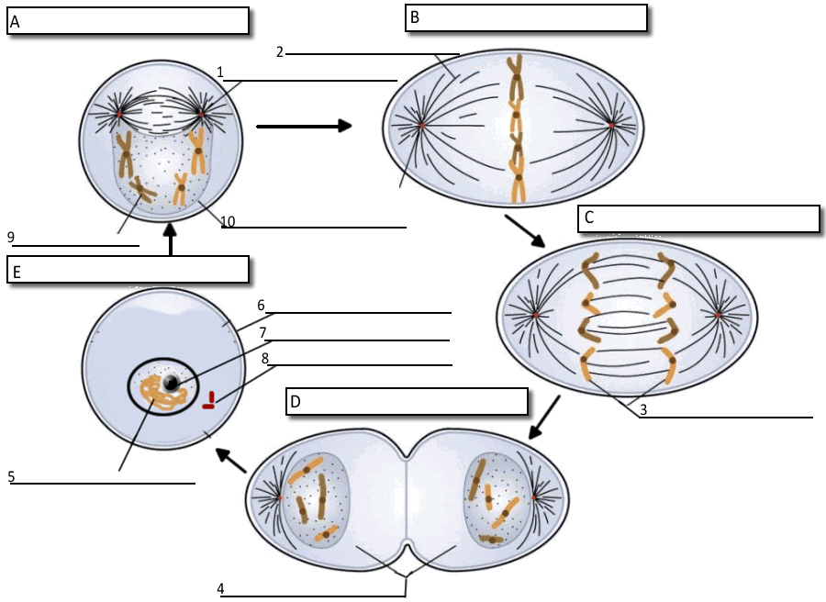

- Fill in the following on the chromosomes.
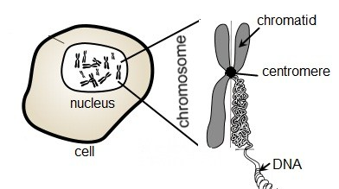
D.
C.
A.
B.
E.

- Fill in the following on the Cell Cycle.

- Asexual reproduction is reproduction with one ____________________. Sexual reproduction requires _____________ parents. This helps create genetic ___________________________.
- The longest phase of the cell cycle is ________________________.
- What occurs during the G1 phase? ____________________________________.
- What happens during:
- Prophase: ______________________________________________________
- Metaphase: ____________________________________________________
- Telophase: _____________________________________________________

- Metabolism SOL Bio 2d, 3bc, 4a.

Write the photosynthesis equation in the boxes below.

+ +

___________________________ is how plants get energy. They receive the energy they need from the ______________. The process of photosynthesis is _________________ meaning it is able to store energy. Plants need ________________ and _____________________ to perform photosynthesis. Plants are considered __________________ which means they make their own food, unlike animals which are _______________________ because they have to consume their own food.

How do plants do photosynthesis at night? What do they do instead?

- The Stoma
The stoma are _______________ on the underside of leaves. ____________________ enters through the stoma and ____________________ exits through the stoma.

- The Chloroplast
This is where ________________ is located and where _____________ occurs. It is the green jelly like substance in the chloroplast. It _________________ light from the sun.

Write the cellular respiration equation in the boxes below.

+ +

Fill in the appropriate vocabulary words below about cellular respiration.

______________________ is how we get energy. We need __________________ and ______________________ to do cellular respiration. _____________ is the cellular energy created during this process. ATP’s structure is very similar to the structure of ___________. Cellular respiration is the ________________________ of photosynthesis.
There are _____ processes to cellular respiration.

- ________________________________
- This is where glucose is broken down.
- It produces _____ ATP’s.
- Anaerobic respiration requires NO ______________________, whereas aerobic does.
- When anaerobic respiration occurs in yeast, they perform ___________________. During this process ________________ is produced.
- When we do anaerobic respiration and fermentation occurs, our cells produce a buildup of _______________________ and our muscles get ________________. There are many beneficial products that come from fermentation. They include: __________________________________________________________.

- Krebs Cycle- It is ___________________________.
- It produces ________ ATPs.
- The Krebs Cycle occurs in the ________________________, which is the powerhouse of the cell.

- Electron Transport Chain
- Makes most of the ________________
- A total of ______ ATPs.

The products from ___________________________ are used as the reactants for __________________ and vice versa. That is why _______________ and animals ____________________ need each other to survive.
- Cell Theory SOL Bio 3a.
- Name the 4 things all cells have.

- Fill in the chart below about the Cell Theory.
Traditional Cell Theory (ABC) | Modern Cell Theory (Don’t Make F’s)
1. | 1.
2. | 2.
3. | 3.
 | 4.

- Explain cell specialization and why it is important.

- Fill in the chart below about cell specialization.

Kingdom | Does it have cell specialization? | Multi or Uni Cellular | Heterotroph or Autotroph | Type of Metabolism | How does it eat?
Animal
Plant
Fungi
Protist
Bacteria

- Prokaryotes SOL Bio 2d, 3bc, 4abf.
- Illustrate a bacterial cell in the box below. Label the following parts and describe their functions:
- Ribosomes
- Capsule
- DNA
- Cell membrane
- Pili
- Cell wall

- Eukaryotes SOL Bio 3d, 3bc, 4a.
- Match each organelle with its appropriate function.
Vocabulary Word | Answer | Possible Answer/Explanation
Vacuole |  | - Helps with motility.
Flagella |  | - Slimy coating on a prokaryotic cell.
DNA |  | - Found in the nucleus.
Cytoplasm |  | - Site of protein synthesis.
Cell membrane |  | - Like warm, moist environments.
Mitochondria |  | - Where DNA is located in the cell.
Chloroplast |  | - Shipping and packaging plant.
Bacteria |  | - Makes ATP.
Capsule |  | - Controls what comes in and out of the cell.
Endoplasmic reticulum |  | - Does photosynthesis, is green.
Cell wall |  | - Site of all chemical reactions in the cell.
Golgi bodies |  | - Has no nucleus or “organelles”.
Prokaryote |  | - Largest organelle in plant cell. Used to hold food and water.
Centrioles |  | - Transport system in the cell. May or may not have ribosomes on it.
Lysosome |  | - Aids in cell division.
Ribosomes |  | - Digestive part of the cell.
Nucleus |  | - Gives cell structure, protection, and shape.

- Define homeostasis. Provide an example.

- Fill in the chart comparing cells.

Characteristic | Plant | Animal | Bacteria | Fungi
Prokaryotic/Eukaryotic
Has nucleus
Has cell wall
Has mitochondria
Has chloroplast
Has ribosomes
Has DNA

- Cell Membrane SOL Bio 2b, 3dce, 4ab.
- Describe the function of each labeled part in the diagram below.
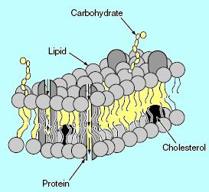

- Describe why the cell membrane is semi-permeable.

- Define passive transport. In which direction would molecules travel? Why?

- Define active transport.

- List the three types of active transport and define them.

- Protists SOL Bio 4abc.
- Describe how the contractile vacuole works in a protist. What is its function?

- Fill in the following chart about protists:
Protist Type | Example(s) | How do they eat/metabolize? | Special Organelles?  (Movement, ingestion, excretion)
Animal-Like
Fungus-Like
Plant-Like

- Nucleic Acids Structure and function SOL Bio 5 e g.
  - Draw and label a section of DNA which includes the items listed below.
    - Nucleotide
    - Nitrogen bases (A, T, C, G) *Be sure to correctly pair them.
    - Sugar (Deoxyribose)
    - Phosphate
    - 3’ and 5’
    - Hydrogen bonds-What strength do they have?

  - Fill in the following chart on nucleic acids.
Characteristic | DNA | RNA
Single stranded
Double stranded
Can leave nucleus
Has Uracil
Has Thymine
Made of nucleotides
Three different types
Holds blueprint for all genetic material
Replicates before cell division
Contains deoxyribose

  - Given the following DNA sequences, construct the complementary strand which would be produced in DNA replication. (***Remember your base-pairing rules!***)

- 5’ A G T T A G G C C 3’

- 5’ G C G C T A A G C 3’

- 5’ C A A T A C G A T 3’

- How does a mutation occur during DNA replication?

- Protein Synthesis SOL Bio h.
  - Fill in the following chart. Word Bank: transcription, translation, mRNA, tRNA, DNA, nucleus, cytoplasm, ribosome, T, A, C, G, U, codon, anticodon, protein, amino acids, and polypeptide chain.

Process in Protein Synthesis | Describe the process (who is involved?) | What is made? | Where does it occur in the cell?
Transcription
Translation
Making of amino acids
Making of protein

  - Using the following codon chart, transcribe and translate the following DNA strands below:
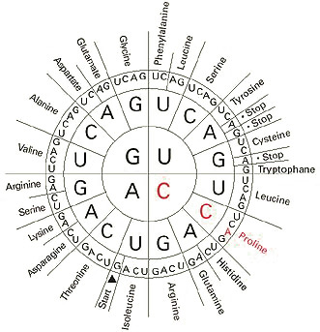
- DNA Template: C G A T A A C T G A T C T A C T A T A T C
Transcripton-mRNA ______________________________________________________________________________
Translation-tRNA ________________________________________________________________________________
Amino Acid Sequence ____________________________________________________________________________
- DNA Template: T A C G T A C G G C G A T A C G A C T A A
Transcription-mRNA _____________________________________________________________________________
Translation-tRNA
Amino Acid Sequence

- Biotechnology SOL Bio 5ij.
  - Describe the process of cloning, and give examples of how cloning is used to benefit mankind.

  - Describe and give examples of how biotechnology creates “ethical issues”.

