Acids and Bases
The degree of acidity or alkalinity (basic) is important in organisms. The body must constantly maintain a near neutral pH (7) in the blood and body tissues. To do this, the body produces buffers that can neutralize acids. Acidic and basic conditions in the body occur due to different metabolic reactions taking place throughout the body.
The force of attraction between molecules is so strong that the oxygen atom of one molecule can actually remove the hydrogen from other water molecules. This reaction is known as dissociation, and it takes place in our cells. Water (H₂0) dissociates into H⁺ and OH⁻ ions. The OH⁻ ion is called the hydroxide ion, while the H⁺ ion is called the hydrogen ion. Free H⁺ ions can react with another water molecule to form the H₃O⁺ or hydronium ion.
Acidity or alkalinity is a measure of the relative amount of H⁺ and OH⁻ ions dissolved in a solution. Neutral solutions have an equal number of H⁺ and OH⁻ ions. Acids have more H₃O⁺ ions than OH⁻ ions. Acids taste sour and can be corrosive. Digestive fluids in the body are acidic and must be neutralized by buffers. Bases contain more OH⁻ ions than H₃O⁺ ions. Bases taste bitter and feel slippery.
When an acid is combined with a base, neutralization occurs. The result of neutralization is a salt and water. Neutralization helps return our body pH to neutral. The process of our bodies maintaining neutral pH so that proteins can work properly without being denaturated (unfolded) is known as homeostasis.

Color the following diagrams according to the key.
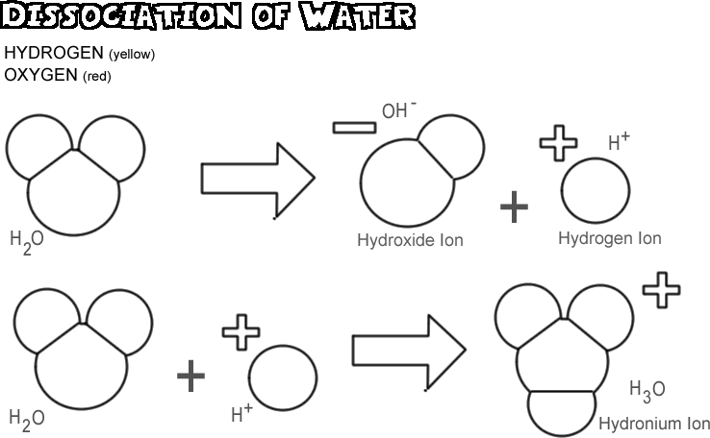

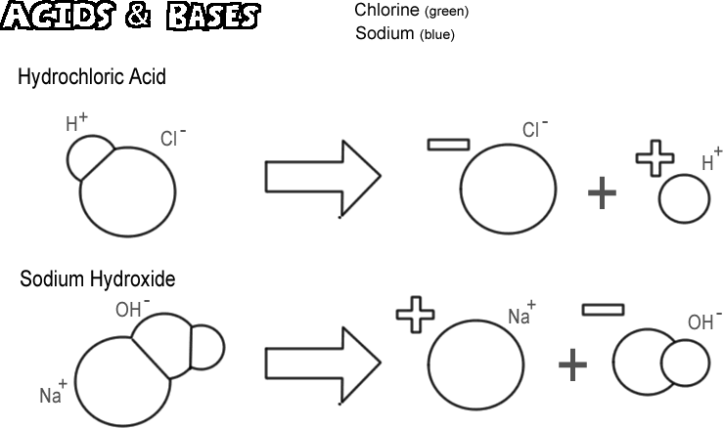
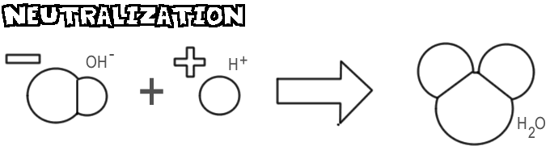Questions:
1. Why is the water molecule so important to organisms?
____________________________________________________________________________________________________________________________

2. What ions form when water dissociates?
______________________________________________________________

3. What is meant by the term alkalinity?
______________________________________________________________

4. What is produced by the body to help neutralize acidic conditions?
______________________________________________________________

5. What is the name for the OH⁻ ions?
______________________________________________________________

6. What is the name for the H⁺ ion?
_____________________________________________________________

7. How does the hydronium ion form? What is its formula?
____________________________________________________________________________________________________________________________

8. Why do most proteins need near a neutral pH?
______________________________________________________________

9. What two substances form from an acid-base neutralization?
______________________________________________________________

10. Acids have an excess of ____________ ions.

