Guided Notes: Acids, Bases, and pH
Warm-Up: Using p. 150-151 in your textbook, answer the following questions.

- What is pH? | - What is an acid?
- The pH scale ranges from… | - What is a base?
Notes
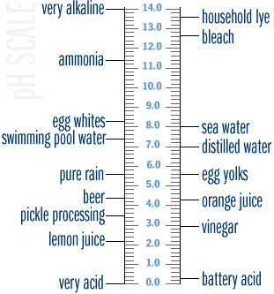  Acids  pH value: | - An acid is any substance that increases the number of…
Bases  pH value: | - A base is any substance which increases the number of…  - A base will also reduce the number of H+ ions in a solution
pH Scale | - Used to measure the degree of ________________ of a substance  - Ranges from…  - pH = 7…  - pH < 7...  - pH > 7…
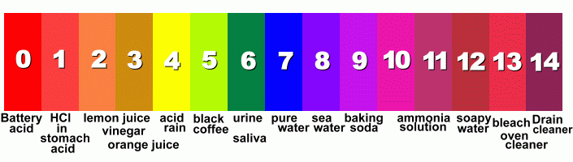
pH of Common Substances

You Try…using the pH scale above, classify the following substances as Acids (A), Bases (B), or Neutral (N).

________ Milk (6.5) | ________ Distilled Water (7) | ________ Tomatoes (4)
________ Soda (3) | ________ Sea Water (8) | ________Oven Cleaner (14)
________ Detergent (10) | ________ Blood (7.4) | ________ Vinegar (5.6)

Good to Know… | - pH is a measure of…  - A ____________________ corresponds to a high concentration of ____________________  - A ____________________ corresponds to a high concentration of ____________________
More about the pH scale…  Examples…  - pH 3 is ______________________________ than pH 4  - pH 3 is ______________________________ than pH 5 | - The pH scale is…  - A change of one pH number actually represents a ____________________ change in the concentration of H+ ions
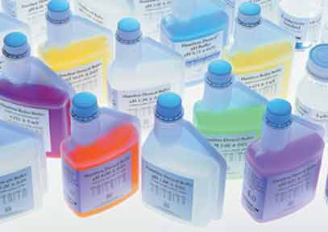
What is a buffer?
Buffers are important because…  Homeostasis: | - Accept __________ ions when they are in excess  - Donate H+ ions when they have been ____________________  - Many biological reactions produce acids & bases, therefore the presence of buffers…  - Help maintain ______________________________
You Try!
Categorize the words from the Word Bank into the appropriate column.

Word Bank | Acid | Neutral | Base
*Slippery | *Lemons
*Bitter | *H+ ions
*Dissolves Metal | *pH = 7
*Sour | *OH- ions
*Soap | *H2O
*pH > 7 | *pH < 7

What is the most likely pH of a tube of toothpaste?  - 3 - 5  - 7 - 9 | An extremely strong base would have a pH of?  - 1 - 7  - 9 - 14
How is a standard atom of H different from a H ion?  - A H ion has an extra electron  - A H ion is missing an electron  - A H ion has an extra proton  - A H ion is missing a proton | Healthy environments for life have a pH closest to?  - 4  - 7  - 9  - 13
What might happen if you mixed a strong acid with an equally strong base?  - An explosive chemical reaction would result  - The acid would destroy the base  - The base would destroy the acid  - A pH-neutral substance would form | What might happen if buffers did not exist in the human body?  - Our bodily fluids would become too acidic/basic  - Our stomach acid would not be able to break down food  - Our cells would be unable to process glucose  - We would not be able to inhale oxygen into our lungs

