Name: __________________________________________________Date: _________________Block: _____

Biochemistry Test Review
Part I: pH

- A neutral pH = __________

- Basic or alkaline pH range is from __________ to __________

- Acidic pH range is from __________ to __________

- List two characteristics you could use to identify an acid: _____________________________________

___________________________________________________________________________________

- List two characteristics you could use to identify a base: _____________________________________

___________________________________________________________________________________

- For the following three items, write B if it represents a Basic pH, A if it represents an Acidic pH, and N if it represents a Neutral pH:

  - pH between 1 and 6.9____
  - pH between 7.1 and 14____
  - pH of exactly 7____

- For the following substances, write B if it is a Base, A if it is an Acid, or N if it is Neutral:

  - Pure water ____
  - Vinegar____
  - Bleach____
  - Lime juice____
  - Soap____
  - Digestive juices of the stomach____

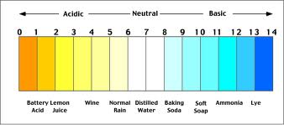

What is the strongest acid in the above scale? _______________________________________
What is the pH of the strongest acid in the above scale? _____________________________
What is the weakest base in the above scale? _____________________________
What is the pH of the strongest base in the above scale? _______________________________

Part II: Water Chemistry

Define polar: ______________________________________________________________________________
Draw a water molecule and label the oxygen and hydrogen:

Label the covalent bond and the hydrogen bond:

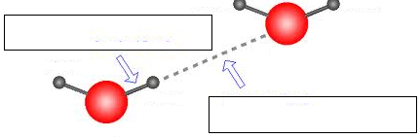

A student dissolves table salt in water to create saltwater.
.
What is the solute? ___________________________________________

What is the solvent? ___________________________________________

What is the solution? ___________________________________________

Define Cohesion: ___________________________________________________________________________

Define Adhesion: ___________________________________________________________________________

What is the most abundant molecule in all living things? ____________________________________________

Is water organic or inorganic? ________________________________________

Part III: Macromolecules

Macromolecule | Monomer | Elements | Function | Examples
Carbohydrate
(polysaccharide)
Lipid

Protein

Nucleic acid

Another word for protein is __________________________
(because they contain PEPTIDE bonds)
Label the parts of a nucleotide:
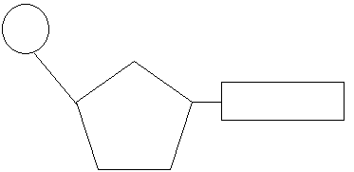

Part IV: Enzymes

Enzymes usually end in what three letters? ____________________
Enzymes are what type of macromolecule? ____________________
List two things that affect how an enzyme works.
______________________________________________________________________________
______________________________________________________________________________
Define metabolism: ___________________________________________________________________
Label the enzyme, substrate, enzyme-substrate complex, and products in the diagram:
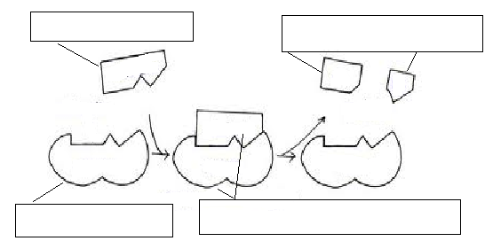

What is the term used to describe the energy needed to ACTIVATE a reaction started? ______________________________________________________________________________
Part V: Matter
Fill in the atomic symbol for the following elements:
Carbon | Hydrogen | Oxygen | Nitrogen | Phosphorus

What is the basic unit of MATTER? ________________________________________
Name the three particles that make up and atom: _______________________________________________
Define and give an example for:
Physical change: _________________________________________________________________________
Chemical change: ________________________________________________________________________
What makes a molecule organic? What element must it contain? ___________________________________
If a molecule does not contain carbon, what do we classify it as? __________________________________

The apparatus represented in the diagrams was used to investigate the effect of temperature on fermentation in yeast. Each of two flasks containing equal amounts of a glucose-yeast solution was submerged in a controlled temperature water bath, one at 20ºC and one at 35ºC. The total number of gas bubbles produced by the solution in each flask was recorded every 5 minutes for a period of 25 minutes. The data are summarized in the table shown
Time (minutes) | Total number of bubbles produced
Temp. | 20ºC | 35ºC
5 | 0 | 5
10 | 5 | 15
15 | 15 | 30
20 | 30 | 50
25 | 45 | 75
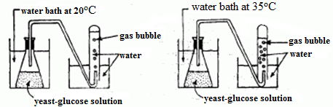 .

Using the information in the data table, construct a graph following the directions below.
- Mark an appropriate scale on each axis
- Plot the data for the number of bubbles produced at 20ºC on the grid. Surround each point with a small triangle and connect the points. 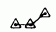
- Plot the data for the number of bubbles produced at 35ºC on the grid. Surround each point with a small circle and connect the points.
- Label your axes and add a title.

Number of Bacterial Colonies
Number of Bacterial Colonies
Number of Bacterial Colonies
Number of Bacterial Colonies

