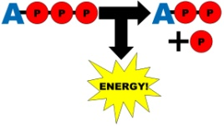
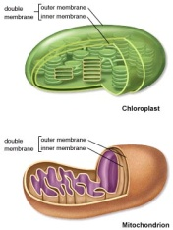
Cell Energy Review
- What type of cell has a true nucleus?

- List the Cell Theory. (Hint: A,B,C)

- What do Prokaryotic cells lack?

- What is the energy molecule? (write full name and abbreviation)

- Define cellular respiration.

- Define photosynthesis.

- Write the equation for photosynthesis.

- Write the equation for cellular respiration.

- List the 3 steps of cellular respiration.

- List the products of photosynthesis.

- List the products of cellular respiration.

- Lists the raw materials for photosynthesis.

- List the raw materials for cellular respiration.

- What is the relationship between photosynthesis and cellular respiration?

- What does aerobic respiration require?

- What pigment makes plants appear green?

- What is the thylakoid in a chloroplast?

- What are the grana in a chloroplast?

- Where does cellular respiration take place?

- Where does photosynthesis take place?

- What is the modern cell theory? (Hint: Don’t Make F’s)

