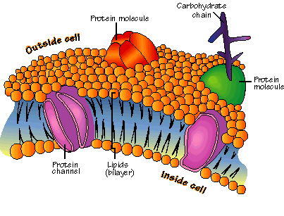
Cell Membrane Review
Directions: Read each questions carefully and answer the following questions using your notes.

- What is the plasma membrane?

- Define the term homeostasis.

- How does it maintain homeostasis?

- List 3 characteristics of the plasma membrane.
a.
b.
c.

- What is selective permeability?

- List 3 functions of the plasma membrane.
a.
b.
c.

- Describe the structure of the plasma membrane (what is it composed of?).

- What is hydrophilic refer to?

- What does hydrophobic refer to?

- Why is the plasma membrane referred to as the fluid mosaic model?

- What is the function of cholesterol in the cell membrane?

- What does the transport protein do in the cell membrane?

- The carbohydrates in the plasma membrane functions by playing a role in _____________ with other cells.

