Guided Notes: Early Scientists and the Cell Theory
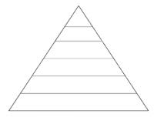
Levels of Organization (smallest to largest)
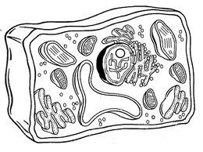  A CELL is… | - Cells were unknown until the invention of the ________________________ in the 1650’s.
Anton van Leeuwenhoek  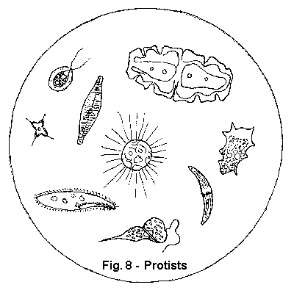  (1632-1723) | - Observed pond water, sour milk, blood and semen  - Named the tiny living organisms he saw…  - Invented the 1st…
Robert Hooke  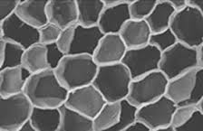  (1635-1703) | - Studied slices of cork  - Named the tiny structures he saw ________ because they reminded him of the small rooms monks slept in  - He was actually viewing…
Matthias Schleiden  (1804-1881) | - 1804: German botanist concluded that…
Theodor Schwann  (1810-1882) | - 1839: German physiologist concluded that…
Rudolf Virchow  (1821-1902) | - 1858: German physician concluded that…
3 components of the Cell Theory

Modern Cell Theory
- The cell contains hereditary information (__________) which is passed on from cell to cell during (_______________________________).
- All cells are basically the same in chemical composition and metabolic activities.
- All basic chemical and physiological functions are carried out _______________ of cells.
- Cell activity depends on the activities of…

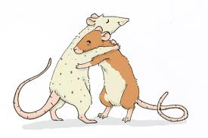  Spontaneous Generation |  | - Until the 1850’s, most people believed that living things could spontaneously appear from…  - EX: Mice could be created by…
Francesco Redi  (1626-1697) |  | - 1st to challenge…  - Did not accept the idea that flies came from rotting meat
Redi’s Experiment  (1668)  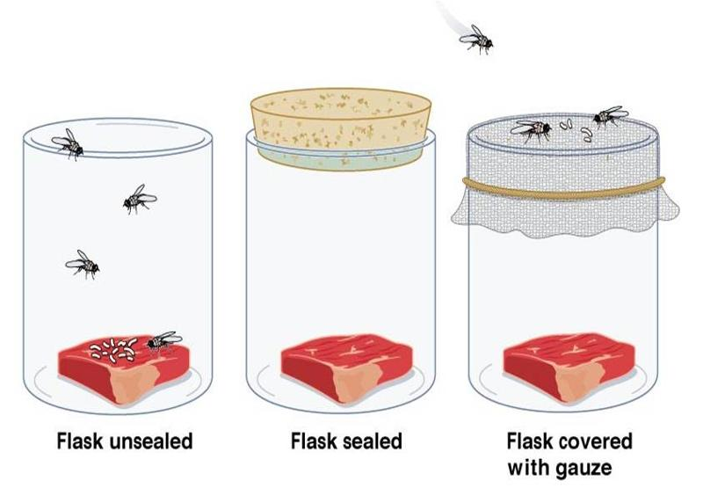 |  | - IV:  - DV:  - Hypothesis: If a jar containing rotting meat is covered, then…  - Conclusion: Flies lay eggs, eggs grow into maggots, maggots grow into flies. If flies cannot lay eggs...
Objections to Redi |  | - Sealing the jar kept…  - Accepted the notion that large organisms could not spontaneously generate, but…
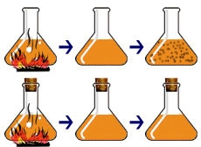  Lazzaro Spallanzani (1729-1799) |  | - Microbes that spoil food come from the air and can be killed by boiling.  - IV:  - DV:  - Hypothesis: If air is allowed to reach food, then…
Spallanzani’s Experiment  (mid-1700’s)  Flask 1:  Flask 2:  Results: |  | 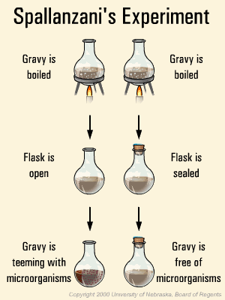
Objections to Spallanzani  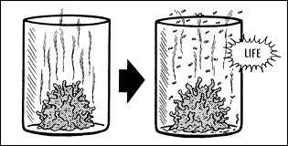 |  | - Sealing the flask…
Louis Pasteur  (1822-1895) |  | - Supported the idea that…  - Invented _________________________ (sterilization by heat)  - Developed a special “swan-neck flask” which…
Pasteur’s Experiment (mid-1800’s)  IV:  DV:  Hypothesis: |  | 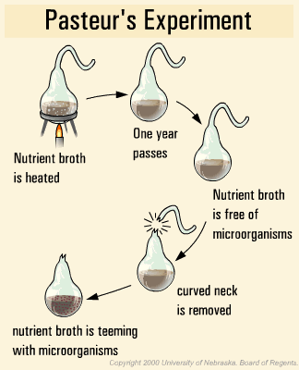
SOL Practice Questions
1. Which of the following came first in the scientific study of living things?  a. Light microscope c. Cell Theory  b. Electron microscope d. Model of DNA | 2. The results of Pasteur’s experiment helped Pasteur to —  a. isolate the virus responsible for smallpox  b. reject the theory of spontaneous generation  c. convince people to cover food  d. produce a vaccine against rabies
3. Francesco Redi performed an experiment in 1668. In the experiment, he placed rotting meat in two jars. The first jar was left open. After a few days, fly larvae were found on the decaying meat inside. The mouth of the second jar was covered with gauze. After a few days, the decaying meat inside was free of fly larvae, but larvae were found on the gauze. This experiment supports the hypothesis that —

a. fly larvae only come from adult flies c. Adult flies are not attracted to decaying meat
b. fly larvae prefer fresh meat d. Decaying meat produces fly larvae
A Cloze Activity on the Cell Theory
In 1665, Robert Hooke, an English scientist, used a crude compound light microscope to examine thin slices of cork from the bark of an oak tree. He observed that the (1)__________ was composed of tiny, (2)__________ boxes similar to a (3)__________. Hooke called the boxes (4)__________ because they reminded him (5)__________ the small, boxy living (6)__________ of monks. Their rooms (7)__________, in fact, called cells. (8)__________, we know that the (9)__________ Hooke observed were the cell (10)__________ of dead plant cells. (11)__________ published his drawings and (12)__________ which led other scientists (13)__________ that time to look (14)__________ evidence of cells.

In (15)__________ 1830’s, two German scientists, (16)__________ Schleiden and Theodor Schwann (17)__________ able to view many (18)__________ organisms with microscopes and (19)__________ some important conclusions. Schleiden (20)__________ a microscope to observe (21)__________ and concluded that all (22)__________ are composed of cells. (23)__________ made similar observations about (24)__________ cells.

The observations and (25)__________ of scientists from the (26)__________ 17th century to the (27)__________ of Schwann and Schleiden (28)__________ summarized into the cell (29)__________, one of the most (30)__________ ideas of modern biology.

(31)__________ cell theory is made (32)__________ of three main ideas…

- (33)__________ organisms are composed of (34)__________ or more cells. An (35)__________ may be a single (36)__________, such as an amoeba (37)__________ a bacterium. Larger organisms, (38)__________ as humans, are composed (39)__________ many cells.

- The cell (40)__________ the basic unit of (41)__________ of organisms. In the (42)__________ way that the basic (43)__________ of matter is the (44)__________, the basic unit of (45)__________ is the cell.

- All (46)__________ come from pre-existing cells. (47)__________ come from the reproduction (48)__________ previously existing cells, a (49)__________ in which cells reproduce (50)__________ copies of themselves.

All | Animal | Are | At | Atom
Basic | Cell | Cells | Cells | Cells
Cells | Conclusion | Cork | Descriptions | Different
Draw | Exact | For | Hollow | Honeycomb
Hooke | Is | Late | Life | Mathias
Of | Of | Of | One | Or
Organism | Organization | Plants | Plants | Process
Quarters | Same | Such | Schwann | The
The | Theory | Time | Today | Unit
Up | Used | Walls | Were | Were

