|  |  |
| --- | --- |
| **Guided Notes: Enzymes** | |
| enzymeWhat is an **ENZYME**? | * An enzyme is a ____________________ that speeds up/slows down (circle one) a chemical reaction * **CATALYST**: |
| enzymeHow does an enzyme work? | * An enzyme works by lowering ____________________ energy * **ACTIVATION ENERGY**: |
| What does this look like?  *Label the graph to the right with the following terms:   1. Reactants 2. Products 3. Catalyzed Reaction (w/an enzyme) 4. Uncatalyzed Reaction (w/out an enzyme) | activationenergy1 |
| **Enzyme Action (Step-by-Step)**  enzyme5*Explain what “Lock & Key” means in your own words.  \***Word Bank**: Enzyme (2x), Active Site, Substrate, Products, Enzyme-Substrate Complex | 1. Enzyme binds to one or more of the _____________ in a reaction  * The reactants that bind to the enzyme are called ____________________ * The site where the enzyme and substrate bind is called the… ________________________________ * The shape of the _________________________ is very specific (LOCK & KEY) to the ____________________  1. The __________________________________________________ is formed when the enzyme and substrate connect to each other, this **bonding lowers ACTIVATION ENERGY** 2. ____________________ is released from the enzyme-substrate complex  * **KEY POINT:**  1. The _______________ is now free to react with another _______________ |

**Enzyme Practice**

1. Enzymes are which type of macromolecule? ____________________________________________________________________________________

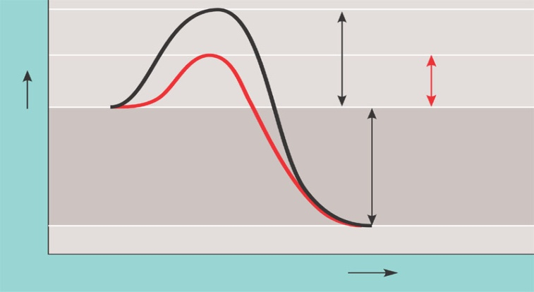2. What do enzymes do? ____________________________________________________________________________________________________________________

3. **Label** the picture below with the following terms:

|  |
| --- |
| 1. Activation Energy w/Enzyme 2. Activation Energy w/out Enzyme 3. Energy Released from Reaction 4. Enzyme Activity 5. Time |

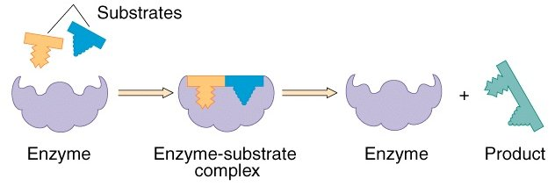4. ***Explain*** what takes place in each step of the diagram below:

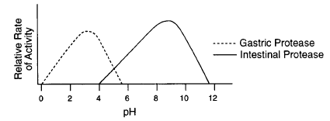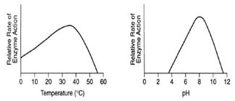

|  |  |
| --- | --- |
| 1. What 2 environmental conditions can affect the activity of an enzyme?    1. What is the optimal pH at which this enzyme functions? 2. What is the optimal temperature at which this enzyme functions? 3. What happens when the pH is 2? | 1. What is the optimal pH for the enzyme intestinal protease? 2. What is the optimal pH for the enzyme gastric protease? 3. Which enzyme works best in an acidic environment? |

**+**