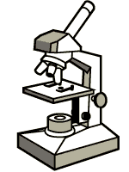  What scientific advancement made the discovery of cells possible?  Cell Structure and Function Test Review | 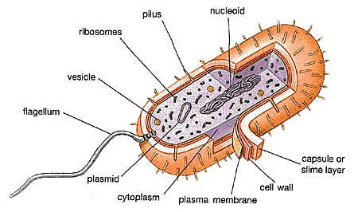
Write the letter of the scientists name next to their contribution to the cell theory.  - Robert Hooke  - Anton van Leeuwenhoek  - Matthias Schleiden  - Theodor Schwann  - Rudolf Virchow | - All cells come from pre-existing cells  - First to see cells; coined the term “Cell”  - All animals are made of cells  - Looked at pond water and saw tiny microorganisms called “Animalcules”  - All plants are made of cells
What are the seven premises of the Cell Theory? | Compare and Contrast: Prokaryote vs. Eukaryote  Compare and Contrast: Plant vs. Animal Cells
What is an organelle? | List the four parts common to ALL cells.
Write the name of the organelle next to its function.  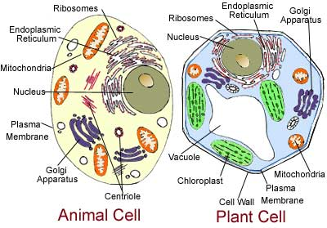  Word Bank: Vacuole, Chloroplast, Cell Membrane, Endoplasmic Reticulum, Lysosome, Mitochondria, Cell Wall, Ribosome, Nucleus, Golgi Apparatus | - Intracellular highway  - Brain of the cell; controls all cell activity  - Site of photosynthesis in plants  - “Powerhouse” of the cell; site of cellular respiration  - Garbage disposal (contains digestive enzymes)  - Site of protein synthesis; these organelles are made in the nucleolus  - Packages cellular products for transport and export from the cell  - Storage of water and food  - Regulates what enters and leaves the cell  - Outermost boundary of a plant cell
Write the letter of the scientists name next to their contribution to our understanding of spontaneous generation.  - Francesco Redi  - Lazzaro Spallanzani  - Louis Pasteur | - Developed a special “swan-neck” flask to help disprove the idea of spontaneous generation.  - Used jars of rotting meat to prove that flies came from maggots, not meat.  - Believed that the microbes which spoil food come from the air and can be killed by boiling.
Multiple Choice:  In what type of cell would you find a chloroplast?  - Prokaryote b. Animal  c. Plant d. Fungus  In which of the following pairs are the terms NOT related?  - Nucleus-DNA - Chloroplast-chlorophyll  - Flagella-Chromatin - Cell Wall-Cellulose  A bacterium is classified as a prokaryote because it…  - Has cilia. - Has no nucleus.  - Is a single cell. - Has no DNA.  What is the difference between a prokaryote and a eukaryote?  - The need for nutrients. - Plasma membranes.  - Membrane-bound organelles. - Cell Walls.  Which of the following structures is NOT found in both plant and animal cells?  - Chloroplast - Ribosomes  - Cytoskeleton - Mitochondria  According to the cell theory, which statement is correct?  - Cells are basically unalike in structure.  - Cells come from pre-existing cells.  - Mitochondria are found only in plant cells.  - Viruses are true cells.  Which organelle is present in the cells of a mouse, but not in the cells of a bean plant?  - Cell Membrane - Chloroplast  - Centriole - Cell Wall | 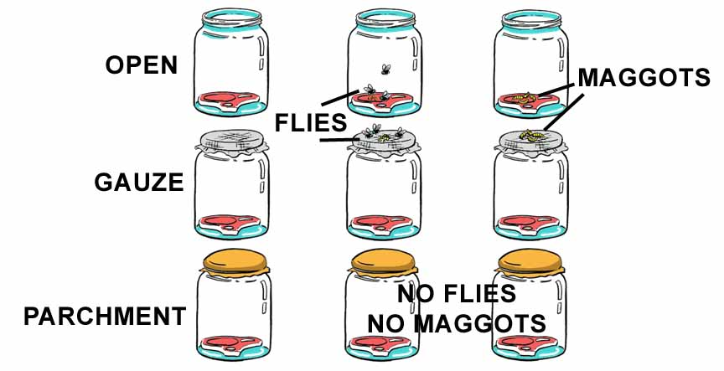  Which scientist performed the above experiment?  IV:  DV:  Hypothesis:  Constants:  Conclusion:  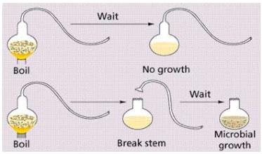  Which scientist performed the above experiment?  IV:  DV:  Hypothesis:  Constants:  Conclusion:

