Guided Notes: Cell Transport
Prokaryotic Cells  - Ex: |  | Eukaryotic Cells  - Ex:
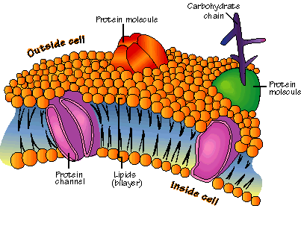  Cell Membrane | - What does it do?  - Main Parts:
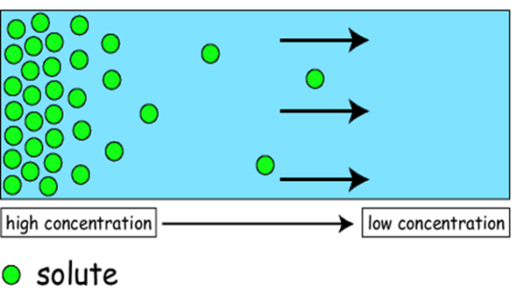  Diffusion | - Movement of particles from an area of…  - Particles spread out until…
Osmosis | - Diffusion of _______________ across a selectively permeable membrane (i.e. the cell membrane)
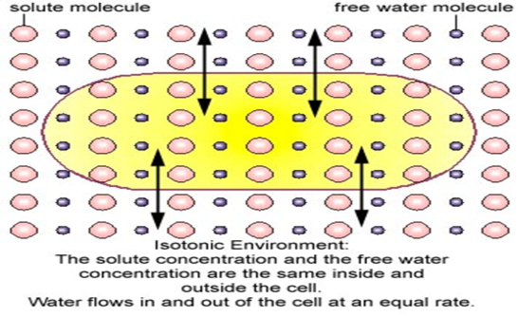  Isotonic Solution | - ISO:  - Concentration is…
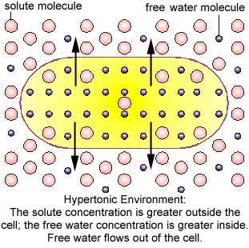  Hypertonic Solution | - HYPER:  - Solution has more _______________ (particles) than the other side of the membrane (inside the cell)
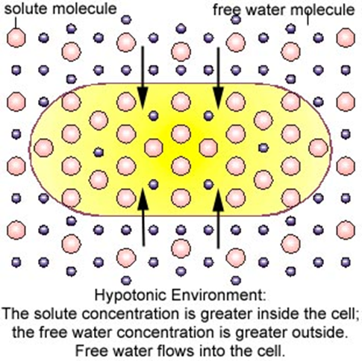  Hypotonic Solution | - HYPO:  - Solution has __________ solutes (particles) than the other side of the membrane (inside the cell)
Passive Transport | - Movement _______________ the concentration gradient  - Key Point:
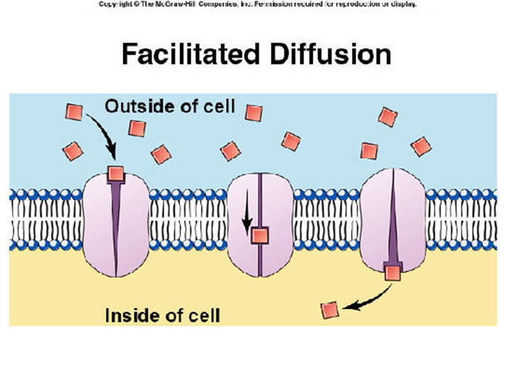  Facilitated Diffusion | - ____________________ within the cell membrane help move molecules across the membrane  - Example:
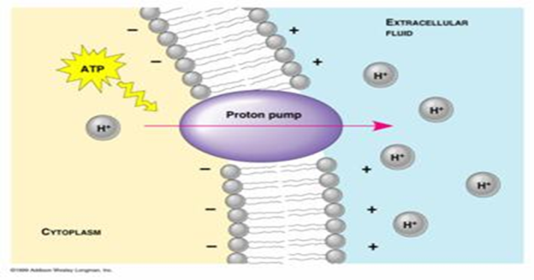  Active Transport | - Movement of molecules _______________ the concentration _______________  - Key Point:
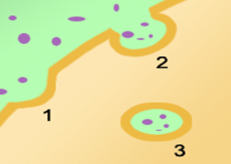  Endocytosis | - Taking materials _________________________ by infoldings of the cell membrane
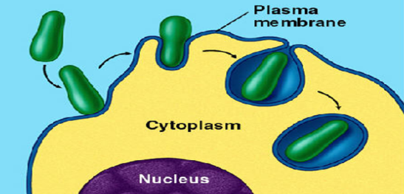  Phagocytosis | - _______________ by surrounding a particle and packaging it into a food vacuole  - Key Point:
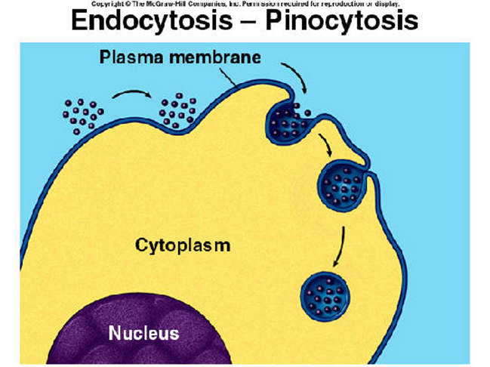  Pinocytosis | - Tiny pockets form along the cell membrane,…  - Key Point:
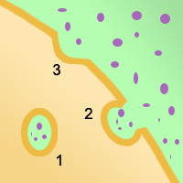  Exocytosis | - Vacuole fuses with the cell membrane,…  - Key Point:

