Guided Notes: The Cell Cycle and Mitosis
BIG IDEA: What is Mitosis?

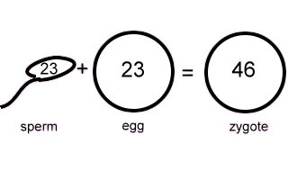
When does Mitosis begin? | - i.e. 1 cell becomes 2 cells, 2 cells become 4 cells…become TRILLIONS!!!
Why do cells make more cells?

Three reasons why cells reproduce by asexual reproduction…
Important Terms  - ____________________: body cells, produced through Mitosis, ours contain 46 chromosomes (23 pairs)  - ____________________: each member of a chromosome pair  - ____________________: (2N) two sets of chromosomes (usually one from each parent), total of 46 chromosomes in people, ex. Somatic cells & Zygotes  - ____________________: (n) half of a complete set of chromosomes, total of 23 chromosomes in people, ex. Gametes (egg and sperm) | Steps of the Cell Cycle  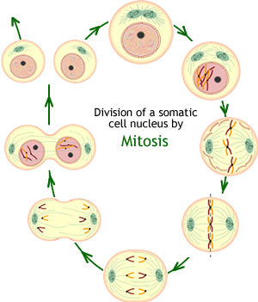
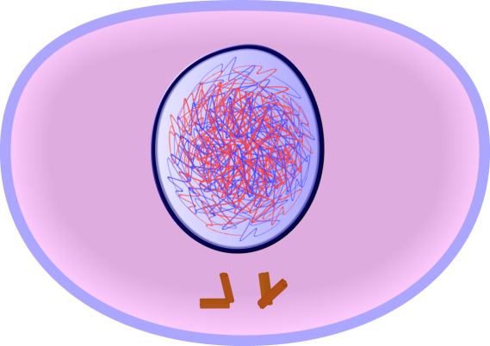  INTERPHASE | - Occurs before Mitosis begins  - Chromosomes are ____________________ (# DOUBLES)  - Chromosomes appear as threadlike coils (____________________) at the start, but each chromosome and its copy (_________________________)condense to sister chromatids by the end of this phase
What are the 3 stages of Interphase?  - Growth Stage 1  - Synthesis  - Growth Stage 2 | - G1:  - S:  - G2:
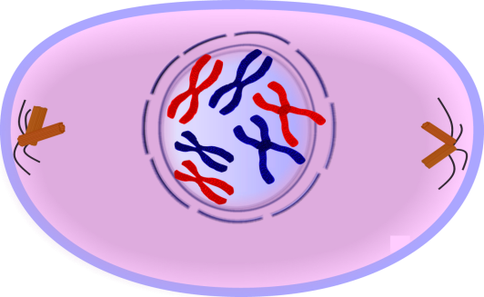  PROPHASE (1st Stage of Mitosis) | - Mitosis begins (cell begins to divide)  - ____________________ (or poles) appear and begin to move to opposite ends of the cell  - ____________________ disappears  - ____________________ form between the poles
METAPHASE (2nd Stage of Mitosis)  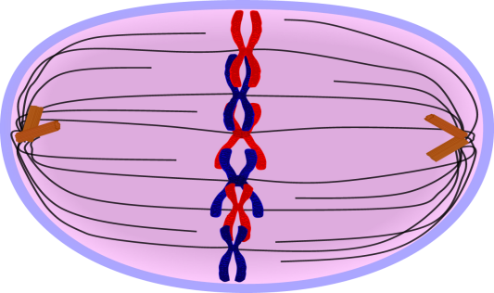 | - Chromatids(pairs of chromosomes) attach to the spindle fibers at the ____________________  - ____________________ move to the equator of the spindle
ANAPHASE (3rd Stage of Mitosis)  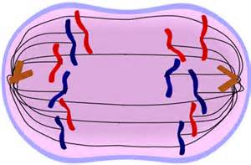 | - Chromatids (pairs of chromosomes)…
TELOPHASE (4th & Final Stage of Mitosis)  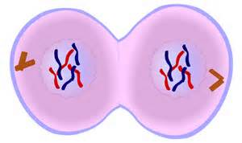 | - 2 new identical nuclei form (nuclear envelopes reform)  - Mitosis ends!
CYTOKINESIS (Occurs after Mitosis)  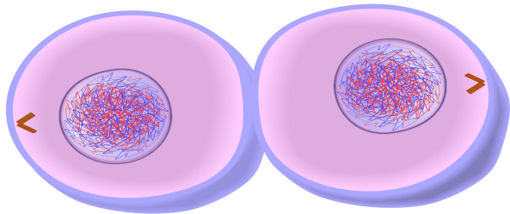  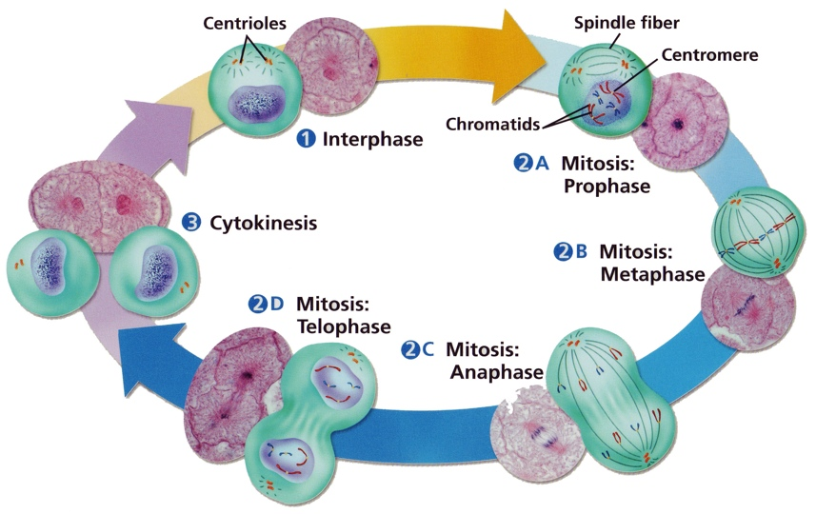 | - Cell membrane moves inward to create two ____________________ cells- each with its own ____________________ with identical chromosomes
REMEMBER…

I:
P:
M:
A:
T:
C:
**

