Guided Notes: The Plasma Membrane
What is the plasma membrane?  *aka cell membrane, fluid mosaic, lipid bilayer | - A flexible barrier between the cell and its environment which…  - HOMEOSTASIS:
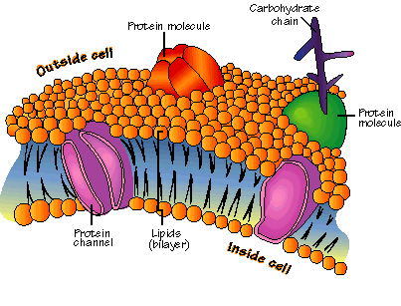  How does it maintain homeostasis? | - Allows nutrients such as glucose, amino acids and lipids to…  - Removes…
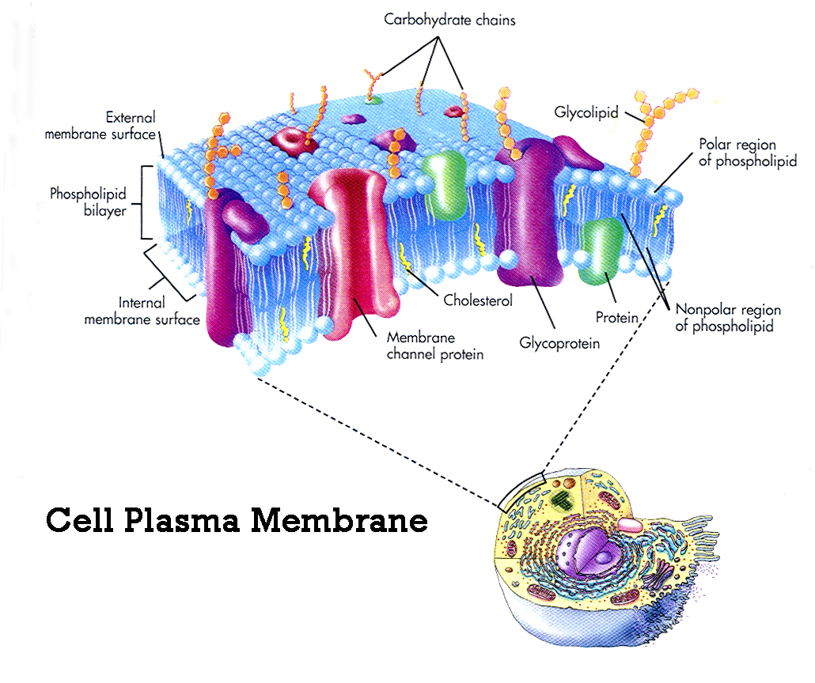  Characteristics of the Plasma Membrane | - Fluid and flexible
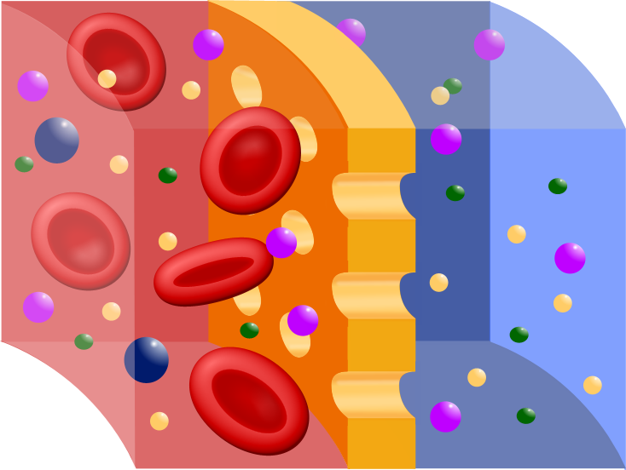  What is selective permeability? | - The membrane allows some molecules to pass through, while keeping others out  - EX:
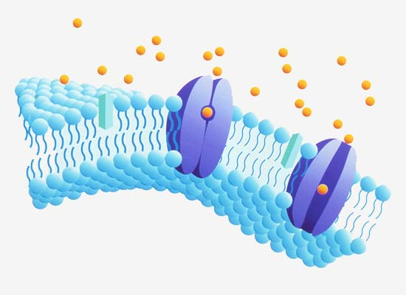  Functions of the Plasma Membrane | - Regulates what enters and leaves the cell  - Acts as a barrier between the cell and its environment
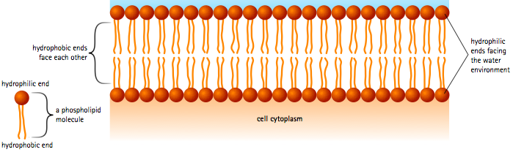  Structure of the Plasma Membrane | - Composed of…
The Phospholipid Bilayer  Hydrophilic:  Hydrophobic: | - _______________________________ allows the membrane to interact with its water environment (both inside and outside of the cell)  - Non-polar fatty acid tails avoid…
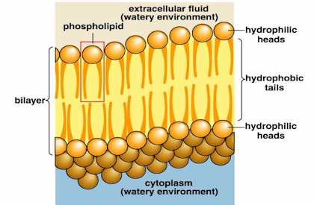  The Phospholipid Bilayer (cont.) | - 2 layers of phospholipids make a sandwich with…
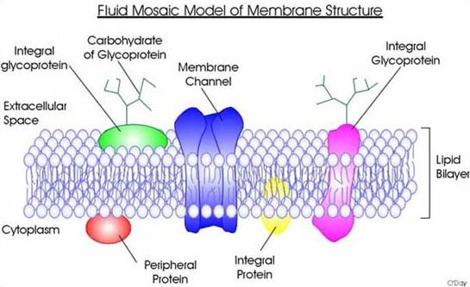  Fluid Mosaic Model | - Fluid:  - Mosaic:
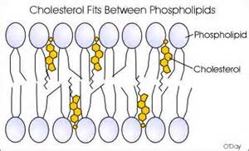  Components of the Cell Membrane | - ____________________: stabilize the membrane by keeping fatty acids tails from sticking to each other  - ____________________: regulates what enters and leaves the cell  - ____________________: communication with other cells
Label the Cell Membrane | Word Bank:  - Carbohydrate Chain  - Cholesterol  - Glycoprotein  - Lipid Tails  - Peripheral Protein  - Phosphate Head (2x)  - Phospholipid  - Phospholipid Bilayer  - Transport/Channel Protein
