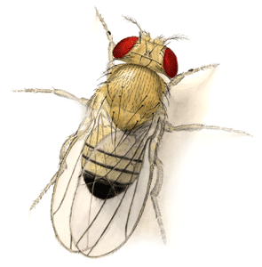
GUIDED NOTES: CHROMOSOMES AND DNA REPLICATION
DNA and Chromosomes  ____________________: single, circular chromosome  ____________________: DNA in the nucleus of the cell in the form of multiple chromosomes | Chromosome Number  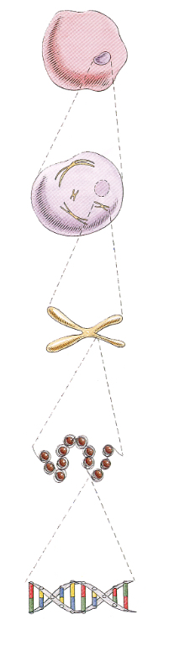  - Examples  - Humans:  - Giant Sequoia Tree:  - Drosophila:
DNA Length  - Extremely long (more than 1m in the nucleus of a human cell!)  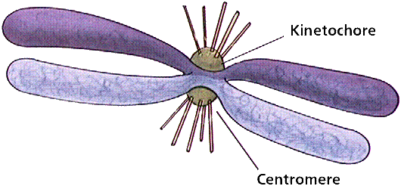  - Question:  - Answer: | Chromosome Structure  - CHROMATIN:  - NUCLEOSOME:  - Pack together to form a thick fiber with loops and coils  - Allows a lot of DNA to…
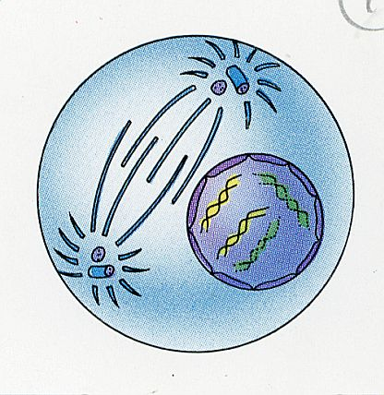  Chromatin  - During which phase of Mitosis (PMAT) does chromatin condense into visible chromosomes? | DNA Replication Facts  - DNA has to be copied…  - During which stage of the Cell Cycle is DNA replicated?  - New cells will need…
DNA Replication  - 2 strands are complementary | 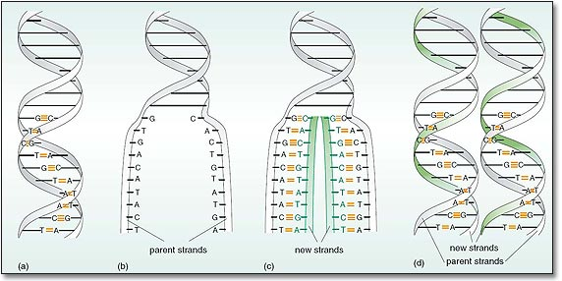
Duplicating DNA  - Copying DNA is called…  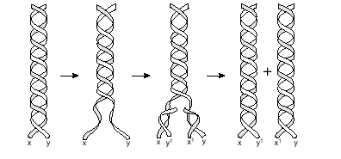  - Results in two DNA molecules that are… | How does replication occur?  - Enzymes…  - “unzipping”:
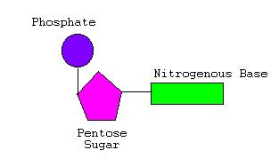  DNA Polymerase  - Enzymes end in…  - Joins individual nucleotides  - “proofreads” new strands to…  - Review: What kind of macromolecule is an enzyme? ____________________ What is the monomer of this macromolecule? ____________ | Proofreading New DNA  - DNA polymerase initially makes about how many errors when base pairing?  - How are these mistakes corrected?  - What is the new error rate AFTER proofreading?
DNA Damage and Repair  - DNA in our body cells (somatic cells) is damaged by…  - Cells must continuously repair…  - _________________________ occurs when any of 50 repair enzymes remove damaged parts of DNA  - DNA polymerase and DNA ligase… | 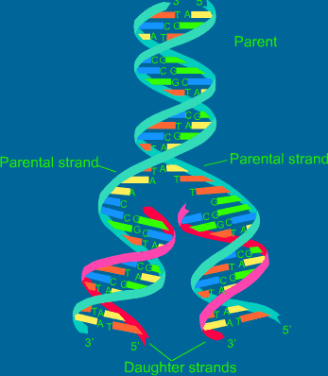  What does DNA replication look like?
A Little Bit of Review…
What are the three parts of a nucleotide? | What is the rule for the bonding of DNA nucleotides (Chargaff’s Rule)?
In eukaryotic cells, which organelles contain DNA? | What kind of macromolecule is DNA?  What is its monomer?
Name the two scientists credited with discovering the double-helical structure of DNA. | What does DNA stand for?  What sugar is found in DNA?

