GUIDED NOTES: Meiosis (Reduction Division)
TYPES OF REPRODUCTION  ASEXUAL  Examples: Binary Fission, Fragmentation, and Budding  SEXUAL  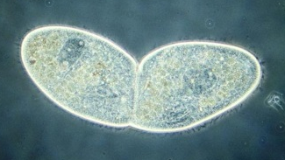 | Organisms which reproduce sexually are made up of two different types of cells.  - _______________: Body cells with a diploid number (2N) of chromosomes  Example:  **What process produces somatic cells?  - _______________: Sex cells with a haploid number (N) of chromosomes  Example:  **What process produces gametes?
GAMETES  - SPERM  - Male Gamete  - OVUM (plural= Ova)  - Female Gamete  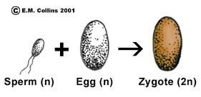 | FERTILIZATION  Definition:  - During ovulation, an ovum is released from the ovary and transported to an area where fertilization can occur  - The result of fertilization is a fertilized egg known as a...  Picture:
HOMOLOGOUS CHROMOSOMES  - Pair of chromosomes (maternal & paternal) that is similar in shape & size.  - Homologous pairs (_______________) carry genes controlling the same inherited traits.  - Each _______________ (position of a gene) is in the same position on homologues.  - Humans have _____ pairs of homologous chromosomes.  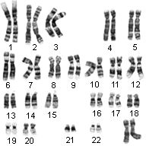 | **Since a homologous pair of chromosomes consists of 4 chromatids, it is called a ____________________  **Each set of homologous chromosomes consists of 2 ____________________  Autosomes  Sex Chromosomes  XY=  XX=
MEIOSIS  - Process in which a single cell goes through _____ nuclear divisions to produce _____ haploid gametes  - During meiosis, _____ cells are reduced to ______ cells  - What would happen if meiosis did NOT occur? | _______________: Egg production in females in which one daughter cells keeps all of the cytoplasm, while the other three receive only genetic material (barr/polar bodies)  _______________: Sperm production in males in which cytoplasm and genetic material are divided evenly among the 4 cells; flagella are added after differentiation.
INTERPHASE 1  - Similar to interphase in ____________________  - Chromosomes replicate (S Phase)  - Centriole pairs replicate  - Nucleus and nucleolus are visible | MEIOSIS 1  - Characterized by the separation of homologous pairs of chromosomes  - 4 stages
PROPHASE 1  - Chromosomes condense  - Nuclear envelope disappears  - Spindle forms  - _______________ occurs: Homologous chromosomes pair up to form a tetrad.  - _______________: 2 chromosomes or 4 chromatids  - Crossing over occurs | Draw a picture of SYNAPSIS.  CROSSING OVER: segments of non-sister chromatids break & exchange genetic material creating genetic diversity  Picture:
METAPHASE 1  - Independent Assortment occurs (orientation of homologous pairs to poles is random) | ANAPHASE 1  - Homologues separate & move to opposite poles
TELOPHASE 1  - Nuclear envelope usually does NOT reform  - Chromosome # in 2 new cells is now __________ because…  - Cytokinesis may or may not occur | MEIOSIS 2  - Proceeds just like Mitosis  - Starts & ends with…
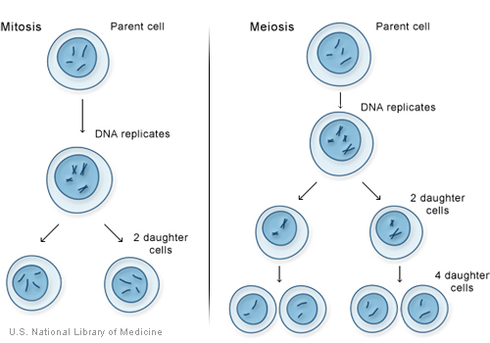

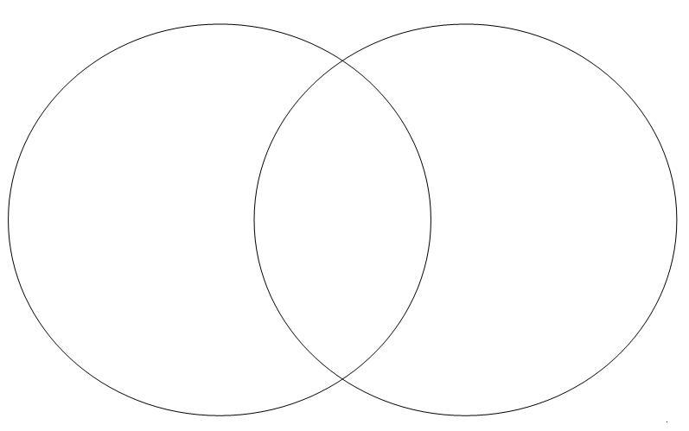

Time for a little practice…
Somatic Cells vs. Gametes: Determine if the cells below are SOMATIC (BODY) CELLS or GAMETES (SEX) CELLS. If a cell is a SOMATIC CELL, write an S in the blank. If a cell is a GAMETE, write a G in the blank.
_____ Adenoid Cell | _____ Epithelial Cell | _____ Zygote
_____ Ovum | _____ Heart Cell | _____ Skin Cell
_____ Pancreas Cell | _____ Squamous Cell | _____ Gallbladder Cell
_____ Sebaceous Cell | _____ Cilia Cell | _____ Brain Cell

Haploid vs. Diploid: Determine if the cells below are Haploid or Diploid. If the cell is Haploid, write an H in the blank. If the cell is Diploid, write a D in the blank.
_____ Lip Cell | _____ Cuticle Cell | _____ Sperm Cell
_____ Cone Cell | _____ Zygote | _____ Muscle Cell
_____ Ovum | _____ Sex Cell | _____ Epithelial Cell

Sentence Completion: Circle the answer that best completes the sentences below.
- Human skin cells are HAPLOID/DIPLOID.
- Human skin cells contain 23/46 chromosomes.
- Human skin cells are SOMATIC/GAMETE cells.
- Human egg and sperm cells are HAPLOID/DIPLOID.
- Human egg and sperm cells contain 23/46 chromosomes.
- Human egg and sperm cells are SOMATIC/GAMETE cells.
- After sperm fertilizes an egg, the resulting zygote has 23/46 chromosomes.
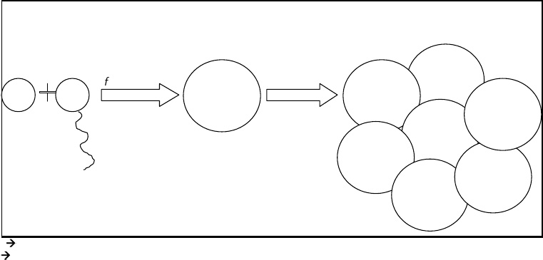
Diagram: Place the following words in the boxes below: Embryo, Gametes, Zygote. Then write the correct number of chromosomes that should be found in each of the human cells depicted in the diagram.

