GUIDED NOTES: The History of DNA
What is DNA?  - DNA stands for _______________nucleic Acid  - DNA is present in the __________ of all _______________ cells  - DNA controls all the _______________ changes which take place in cells  - The kind of cell which is formed (i.e. muscle, blood, nerve, etc) is controlled by DNA  - The kind of organism which is produced (i.e. buttercup, giraffe, herring, human, etc) is controlled by DNA | DNA Molecule  - DNA is a _______________________ (i.e. “Giant Molecule”) made up of a long chain of sub-units (monomers) called ____________________  - Each NUCLEOTIDE has 3 main parts…  - SUN:  - HOUSE:  - POOL:  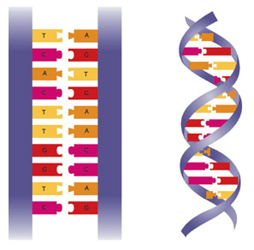
Nucleotide Structure  - In DNA, the phosphate, ____________________ sugar, and a nitrogenous base combine to form a ____________________  *Draw and label a nucleotide below. | DNA Structure  - 4 Nitrogenous Bases
Nitrogenous Bases  - Adenine (A)  - Guanine (G)  - Thymine (T)  - Cytosine (C) | More DNA Structure  - Sides of the Ladder=  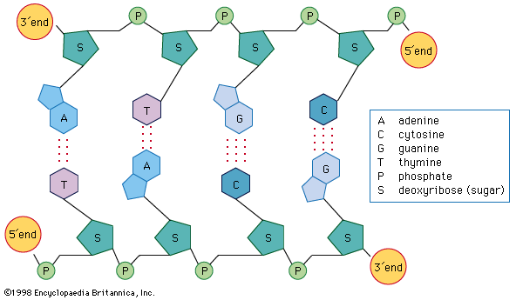  - Rungs of the Ladder=
Discovering DNA: A Team Effort
Frederick Griffith (1928)  QUESTION:  ANSWER: Transformation… | 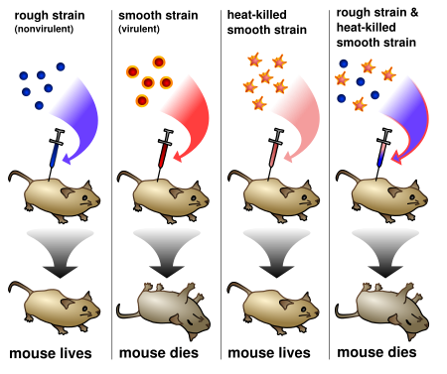
Oswald Avery (1944)  QUESTION:  ANSWER: | 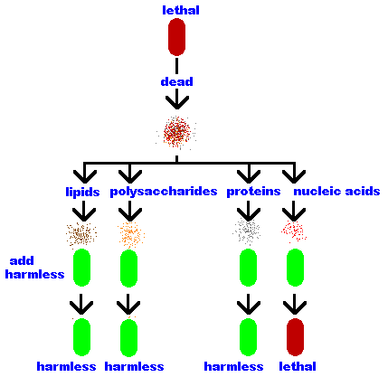
Hershey and Chase (1952)  QUESTION:  EXPERIMENT:  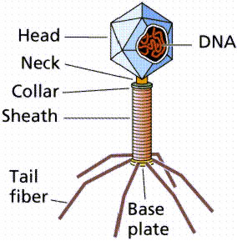  ANSWER: | 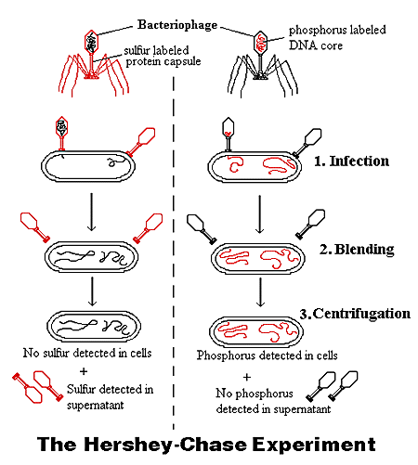
Erwin Chargaff  - DNA base-pairing rules  - Their amounts in a given DNA molecule will be about the same. | What does base-pairing look like?
Chargaff’s Rule  REMEMBER: | Race for the “Double-Helix”  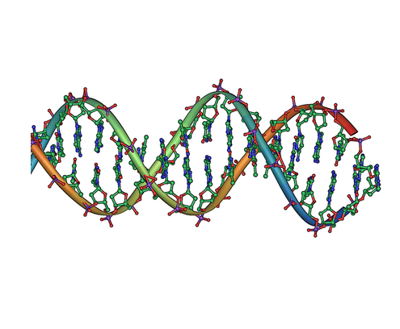  Rosalind Franklin (1952):  Watson & Crick (1953):
Draw the Complementary DNA Strands  CAGGCCTAC  CATTGCAAG | TAAGCGATA  GCCATGAAT

