BIOLOGY TEST REVIEW: MITOSIS, DNA/RNA, PROTEIN SYNTHESIS & MUTATIONS
Label the diagram of the Cell Cycle below.  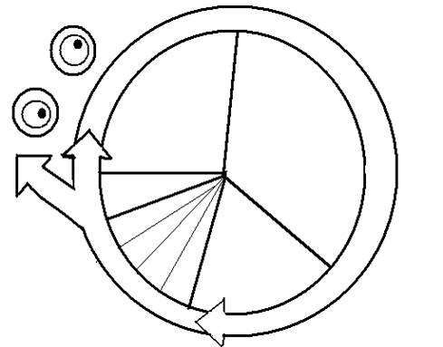 |  |  | Use the Cell Cycle diagram to answer the following questions.  - What is the longest phase of the Cell Cycle? What percentage of time is spent in this phase?  - Interphase is divided into 3 phases. List & describe each phase.
Definition of Mitosis:  3 Reasons Mitosis is important…  *For each of the stages of Mitosis listed below, briefly explain what happens and draw a picture of a cell in that stage. |  |  | Complete the table about Mitosis below.  Parent Cell (n or 2n)  # Daughter Cells Produced  Daughter Cells (n or 2n)  # of Cell Divisions  Relationship between mother and daughter cells  Relationship between daughter cells  Where does it happen?  # of Stages
PROPHASE | METAPHASE |  | ANAPHASE |  | TELOPHASE
Vocabulary: Match the definition with the appropriate term.
_____ 1. division of the nucleus
_____ 2. region of the chromosome where sister chromatids are attached
_____ 3. division of the cytoplasm
_____ 4. phase of mitosis in which spindle fibers attach to the centromere of each pair of sister chromatids
_____ 5. coiled structures made of DNA and proteins
_____ 6. phase of mitosis in which sister chromatids separate and the centromeres divide
_____ 7. a segment of DNA with the genetic instructions to make a protein
_____ 8. two copies of replicated DNA that make a chromosome
_____ 9. the first and longest phase of mitosis
_____ 10. uncoiled DNA
_____ 11. a pair of the same chromosome
_____ 12. phase of mitosis in which the chromosomes begin to uncoil and form chromatin
Word Bank: Anaphase(a), Centromere (b), Chromatid (c), Chromatin (d), Chromosome (e), Cytokinesis (f), Gene (g), Homologous Chromosome (h), Metaphase (i), Mitosis (j), Prophase (k), Telophase (l)
What does DNA stand for? |  | Where is DNA located in the cell? |  | What does DNA look like?
Draw and label a DNA nucleotide. |  |  | In DNA…  - Adenine pairs with…  - Cytosine pairs with…  *Nitrogenous bases are held together by…
Match each scientist with their contribution to the discovery of DNA.

- _____ Franklin  - _____ Griffith  - _____ Hershey & Chase  - _____ Watson & Crick  - _____ Avery  - _____ Chargaff | a. Concluded that DNA was the factor that caused one bacterium to transform into another  b. Used x-ray diffraction to determine DNA structure  c. Concluded that bacteria could be transformed from harmless to lethal from an unknown factor  d. Developed the double-helix structural model of DNA  e. Concluded that the genetic material of a bacteriophage is DNA  f. Showed that the percentages of nitrogenous bases in DNA are present in equal amounts

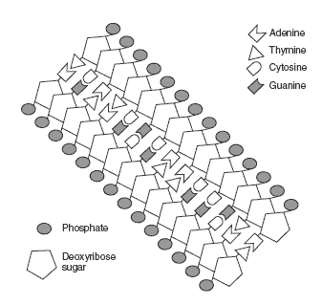
DNA Diagram: Color the DNA diagram below using the following key. Phosphate (RED), Deoxyribose Sugar (BLUE), Adenine (GREEN), Cytosine (PURPLE), Guanine (ORANGE), Thymine (Yellow), Hydrogen Bonds (GRAY). Then, draw a circle around a nucleotide.

DNA Replication: Put the steps of DNA replication in order by writing a number (1-5) in the space before each statement.

_____ Two new molecules of DNA are created.
_____ DNA polymerase attach the free-floating nucleotides to the exposed nitrogen bases.
_____ Helicase begins to break the hydrogen bonds between nitrogen bases.
_____ Cell starts into the mitosis phase of the cell cycle.
_____ Free floating nucleotides pair up with exposed nitrogen bases.
Why does DNA replicate? | When does DNA replicate? | Where does DNA replicate?

What does RNA stand for? |  | What are the 3 types of RNA? |  | Where does Protein Synthesis occur?
Compare and Contrast…  TRANSCRIPTION:  TRANSLATION: |  |  | Compare and Contrast…  CODON:  ANTICODON:
Sequence: Put the following steps of Protein Synthesis in order by numbering 1 through 5.  ________ mRNA leaves the nucleus with the DNA code, and goes to the ribosomes  ________ribosomes make proteins  ________mRNA and tRNA meet in the ribosomes  ________DNA temporarily unzips  ________mRNA nucleotides match up to DNA |  |  | Label the following diagram with these terms: DNA, mRNA, tRNA, ribosome, nucleus, codon, anticodon, and protein.
The code on a DNA strand reads: G C G T A A T G A

- The mRNA strand would read: ____________________________
- Use the mRNA to now make tRNA: _____________________________
- How many amino acids have been coded for by the above DNA strand? _______
- What are proteins composed of? _________________________________
- Where are proteins made? __________________________________
- What is the role of tRNA? ______________________________________________________________
- What is the role of mRNA? _____________________________________________________________
- How many different types of amino acids are there? _______
- What molecule found in the nucleus carries (has) the code for making a protein? _______
- When the information from DNA is passed to RNA this process is called ________________________.
- Give the DNA segment for the following strand of mRNA. A U G G C A ___________________
- Give the mRNA segment for the following strand of tRNA. C U U A A G ___________________
- Where does transcription occur? _______________________________________
- What is a similarity of DNA and RNA? ____________________________________________________
- What base is unique to DNA? ___________________
- What base is unique to RNA? ___________________
- What molecule is RNA transcribed from? _________
- How many bases make up a codon? _______
Complete the diagram below using your knowledge of Transcription and Translation.

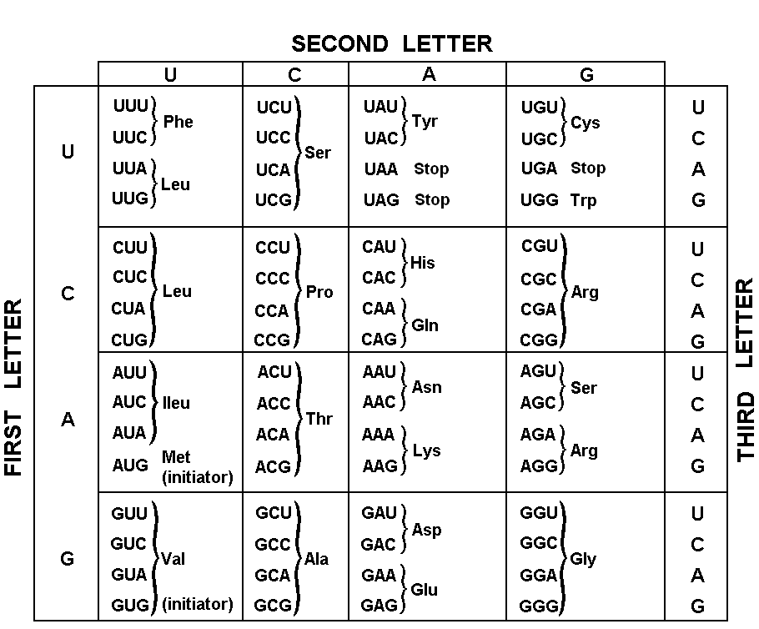
Using a Codon Chart.
- Name the amino acids that are coded by the following codons:

- AAA= e. CAC=
- UAC= f. UGA=
- GGG= g. AGC=
- GGA= h. CCC=

- Write the amino acid sequence to make up the protein: GCA – GGU – CCA – AUG – UGC

- Write the amino acid sequence to make up the protein: GCA – GGU – CCG – AUA – UGC

Define MUTATION:

Deletion | - A piece of one chromosomes breaks off & attaches to a neighboring chromosome
Duplication | - A nitrogenous base is added/inserted to a DNA sequence
Inversion | - A sequence of genes become oriented in the reverse direction
Translocation | - A nitrogenous base or gene is lost/deleted
Substitution | - Extra copies of a gene(s) are added to a chromosome
Insertion | - A nitrogenous base is substituted for another nitrogenous base

