What is a GENE MUTATION?  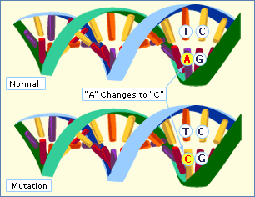 | A mutation which causes a change in…  EX. Substitutions, insertions, and deletions
 | A mutation which involves changes in one or a few nucleotides. (i.e. it occurs at a SINGLE POINT in a DNA sequence)
SUBSTITUTION  *In the example to the right, draw a circle around the nucleotide where the mutation occurred. | - Usually affects no more than 1 amino acid  - EX. T A C G C A T G G A A T  T A C G T A T G G A A T
INSERTION  *In the example to the right, draw a circle around the nucleotide where the mutation occurred. | - 1 base (nucleotide) is inserted into a DNA sequence  - EX. T A C G C A T G G A A T  T A T C G C A T G G A A T
Briefly explain what has happened to the nucleotide sequence in the mutated strand of DNA as a result of the insertion.

DELETION  *In the example to the right, draw a circle around the nucleotide where the mutation occurred. | - Usually has more dramatic effects  - EX. T A C G C A T G G A A T  T _ C G C A T G G A A T  T C G C A T G G A A T
Briefly explain what has happened to the nucleotide sequence in the mutated strand of DNA as a result of the deletion.
FRAMESHIFT MUTATIONS  *Frameshift Mutations Cont.  Examples include… | - Shift the reading frame of a genetic message  - May make a protein unable to perform its original function…WHY?
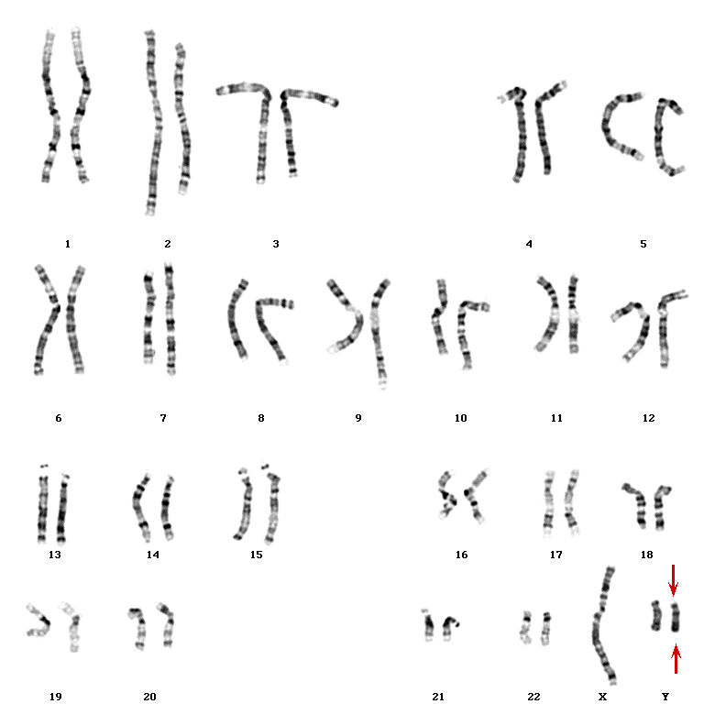 | - Involve changes in the number or structure of chromosomes  - May change the location of genes on a chromosome  - May change the number of copies of some genes
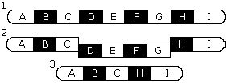
DELETIONS

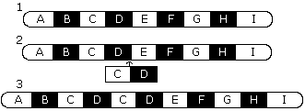
DUPLICATIONS

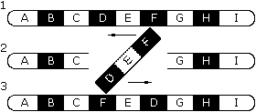
INVERSIONS

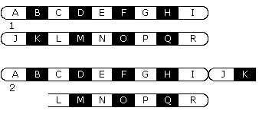
TRANSLOCATIONS

Significance of Mutations | - Most are neutral (i.e. they have little or no effect on gene expression or protein function)  - Some are harmful (causing genetic disorders or cancer) or lethal

