Question | Answer
- What is the name of any organism that is not a plant, an animal, a fungus, or a prokaryote?
- Protists are ____________, this means they HAVE A NUCLEUS!!
- Animal-like protists are called _________. They are divided into 4 phyla...
- Zooflagellates
- Sarcodines
- Ciliates
- Sporozoans

- Characteristics of Zooflagellates  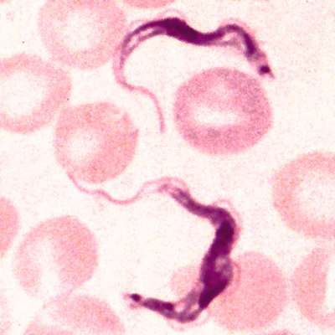 | - Swim using a whip-like tail known as a ______________  - Absorb food through their cell membrane  - Most reproduce ______________ through mitosis and cytokinesis  - Examples: Trypanosoma and Trichomonas vaginalis
- Characteristics of Sarcodines  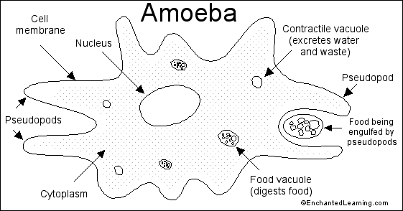 | - Use ________________ or “false-feet” for feeding and movement  - Example: Amoeba
- Characteristics of Ciliates  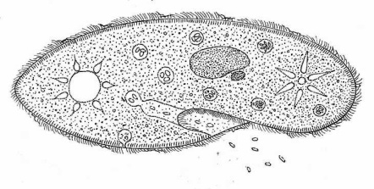 | - Use ____________ or “hair-like” projections for feeding and movement  - Example: Paramecium
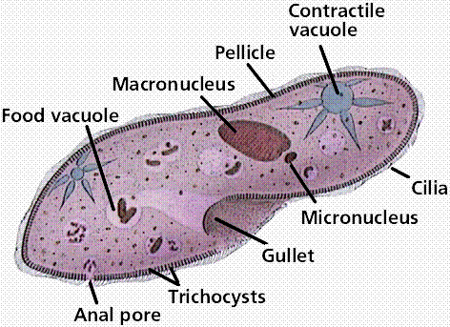  - Anatomy of a Paramecium | - Macronucleus: “working library” of genetic info  - Micronucleus: “reserve copy” of genetic info  - Gullet: Indentation in side that pushes food toward the vacuoles  - Anal Pore: Empties waste materials into the environment  - Contractile Vacuole: Cavity in cytoplasm which collects water
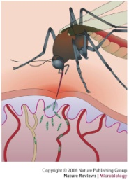  - Characteristics of Sporozoans | - Not capable of moving on their own  - PARASITIC  - Example: Plasmodium
- Plasmodium
- Which animal serves as its host?
- What disease does it cause?
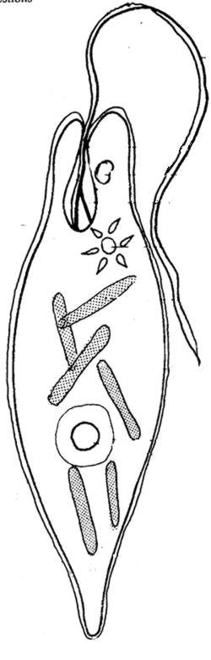
- Plant-like Protists are mostly ___________ and include Euglena, Diatoms, Dinoflagellates, and Algae.
- Euglena | - Flagellum for movement  - No cell wall  - Chloroplasts for photosynthesis
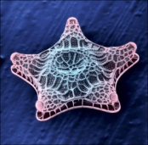  - Diatoms | - 2 part shell made of _______________  - Store food as oil  - Used for filters and petroleum
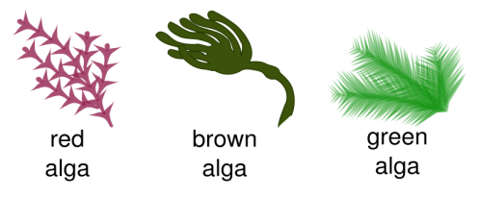  - Algae | - Vary in size  - Commonly called ____________________  - Classified by color
- Characteristics of Fungus-like Protists | - Absorb nutrients from organic material, therefore, they are __________________  - Change form during their life cycle  - Where do they live?

