What does RNA stand for?

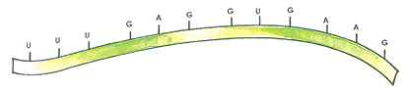
Since RNA is a nucleic acid (like DNA), we know that it consists of monomers called…

The THREE parts of a nucleotide are…  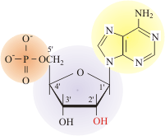 | - Sun:  - House:  - Pool:
DNA vs. RNA  - The sugar in RNA is ____________ instead of deoxyribose which is found in DNA.  - RNA is generally single-stranded, while DNA is ______________________.  - RNA contains the nitrogenous base URACIL instead of ______________. | 1.  2.  3.
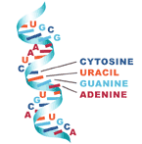  What is RNA? | - Ribonucleic Acid  - A disposable copy of a segment of DNA
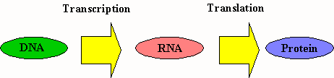  What does RNA do? | - RNA is responsible for assembling _________________ into proteins.  (HINT: What is the monomer of a protein?)
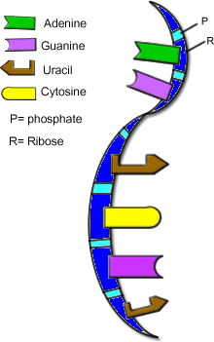  3 Types of RNA | - mRNA:  - rRNA:  - tRNA:
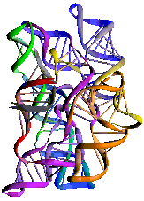  Messenger RNA (mRNA) | - RNA molecules which carry copies of instruction for assembling amino acids into…__________________________.  - “Messengers” from DNA to the rest of the cell…WHY?
Ribosomal RNA (rRNA) | - Proteins are assembled on the ________________ (Hint: these are the smallest organelles in the cell)  - Ribosomes are made up of several dozen proteins plus rRNA
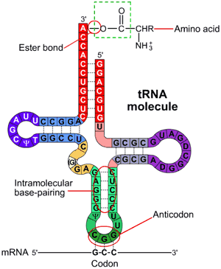  Transfer RNA (tRNA) | - Transfers each amino acid to the ribosome as specified in the instructions coded within…
