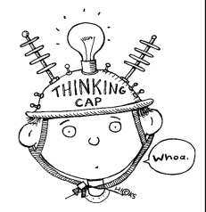
What is the SCIENTIFIC METHOD?
Step 1: | 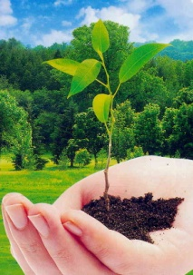  What do you want to know? Can you solve your problem through experimentation?
Step 2: Observation/Research
Step 3: Formulate a Hypothesis | - Example: If ____________, then ___________.
Step 4: | - Develop and follow a STEP-BY-STEP procedure  - Be specific so other scientists can replicate your experiment
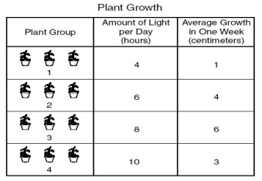  Step 5: Collect and Analyze Results | - Confirm your results by ______________  - Include tables, graphs, diagrams, photos, etc.
Step 6: | - Does your data support your hypothesis?  -If yes…  -If no…  - Do you need to modify your experiment? Could you make any improvements?
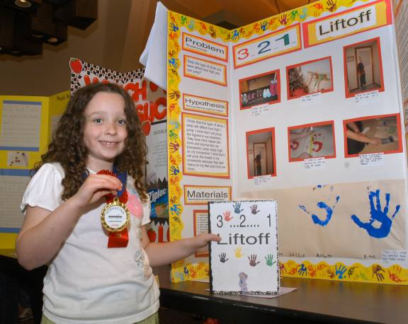
Step 7: Communicate the Results

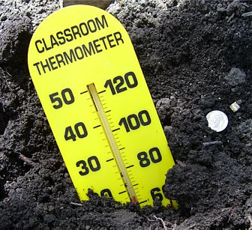
Unit 1 Key Vocabulary
Independent Variable
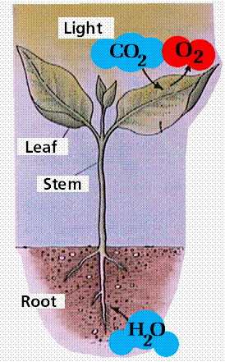
Ex. If soil temperatures rise, then plant growth will increase.
Dependent Variable
Ex. If soil temperatures rise, then plant growth will increase.
Control  Ex. | - Group which receives none of the ______  - May be a “no treatment” group or an “experimenter selected” group  - Serves as a standard of _____________________ for other trials
Constants  Ex. | - All factors that an experimenter chooses to keep the same  - Why is this important?

Mr. Krabbs wants to make Bikini Bottoms a nicer place to live. He has created a new sauce that he thinks will reduce the production of body gas associated with eating crabby patties from the Krusty Krab. He recruits 100 customers with a history of gas problems. He has 50 of them (Group A) eat crabby patties with the new sauce. The other 50 (Group B) eat crabby patties with the sauce that looks just like the new sauce but is really just a mixture of mayonnaise and food coloring. Both groups were told that they were getting the sauce that would reduce gas production. Two hours after eating the crabby patties, 30 customers in Group A reported having fewer gas problems and 8 customers in Group B reported having fewer gas problems.
Which people are in the control group?
What is the IV?
What is the DV?
What should Mr. Krabbs’ conclusion be?

