Guided Notes: Properties of Water
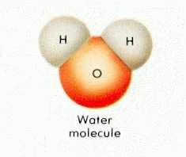
Brainstorm: List 5 things you know about water.
What is water? | - H2O…this means 1 molecule of water contains ________ atoms of Hydrogen and ________ atom of Oxygen.  - Water covers ________ of the Earth’s surface and makes up ________ of all living cells!!
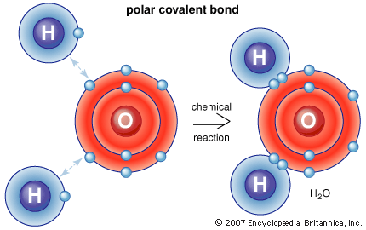  Atomic Structure of Water | - Each Hydrogen atom is held onto the Oxygen atom by a _________________________________.
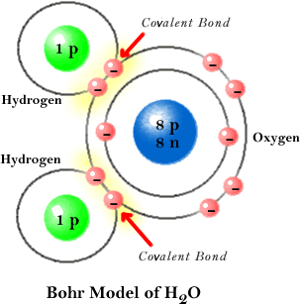  Using the diagram below, complete the table to the right. | HYDROGEN OXYGEN  PROTONS (+)  NEUTRONS (0)  ELECTRONS (-)
What is a Chemical Bond?
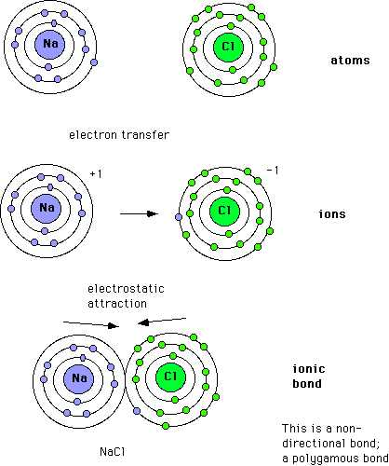
List 4 Types of Chemical Bonds
IONIC BONDING | - An ionic bond forms when 1 or more _______________ are _______________ from one atom to another.  - If a molecule has more protons than electrons, it carries an overall _______________ charge.  - If a molecule has more electrons than protons, it carries an overall _______________ charge.  - Example:
COVALENT BONDING | - A covalent bond forms when _______________ are _______________ between atoms, NOT transferred, the resulting structure is called a _______________.  - Example:
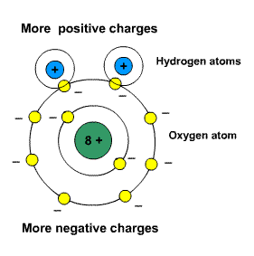  POLAR COVALENT BONDING | - Polar covalent bonds form when sharing occurs in an _______________ manner, the result is a molecule with no net charge.  - Opposite ends of the molecule are partially ________ and partially ________, depending on the distribution of _______________.  - Example:
Good to know… | - _______________ bonds are stronger than _______________ bonds.  - Covalent bonds do not _______________ in water.  - Dissociate means…
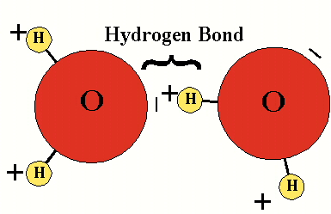  HYDROGEN BOND | - A hydrogen bond forms…  - Easy to break  - Key Point: The numerous special properties of water are made possible by its ability to form multiple H bonds.

BRAIN POP ACTIVITY
- Draw and label a molecule of water. | - What is one effect of water’s “stickiness,” or cohesion?  - The salt that forms in ocean water.  - The surface tension that forms on lakes/ponds.  - The waves you see in lakes & oceans.  - The currents that form in streams & rivers.
- What might happen if water did not have a slight (+) charge on one end & a slight (-) charge on the other?  - Water would not be able to freeze or boil.  - Water would be neither “hard” nor “soft”.  - Water molecules would not clump into droplets.  - Only saltwater could exist on Earth. | - In the movie, Tim says that water’s versatility allows for chemical reactions vital to life. What does this mean?  - Water has many uses & applications.  - Water can be found in many places on Earth.  - Water can exist as a solid, liquid, or gas.  - Water often contains many chemicals.
- Water is known as the “universal solvent.” What is the best synonym for “solvent”?  - A substance that dissolves other substances.  - A substance that exists as a liquid at room temperature.  - A substance that is found almost anywhere on Earth.  - A substance that is necessary for life. | - If you weigh 100kg, how much would you weigh if all water was removed from your body?  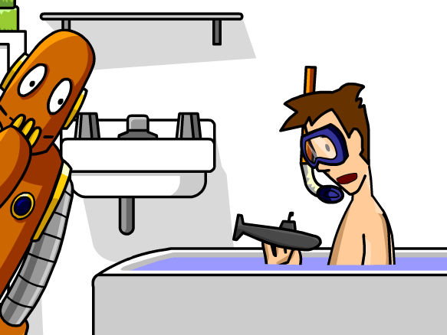  - 65kg  - 45kg  - 50kg  - 35kg

