Bacteria and Protist Review
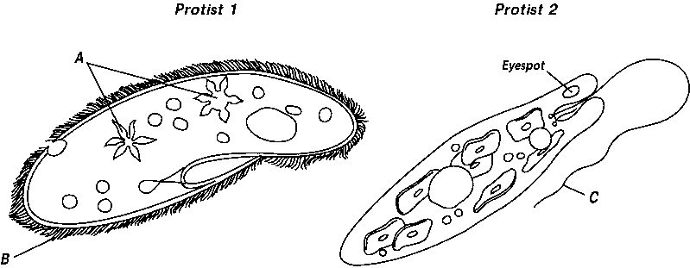

1. Identify the following structures and then explain its function:
a.
b.
c.
2. What is the function of the eyespot in Protist 2?

3. Name Protist 1:
4. Name Protist 2:
5. What is the name of animal-like protists?

6. List examples of animal-like protozoans.
- ____________________
- ____________________
- ____________________
7. What is a heterotroph?

8. What is an autotroph?

9. Name the type of autotrophic protists.

10. Describe the movement of an amoeba.

11. Describe how euglenas move.

12. Describe how paramecia move.

13. Are euglenas heterotrophic or autotrophic? Explain.

14. How do fungus-like protists reproduce?

15. What cell type are all bacteria classified as?

16. What process do bacteria cells reproduce?

17. Organisms that they break down large chemicals in dead organisms into small chemicals are called __________________.

18. Where is the genetic information found in a bacterial cell?

19. What are the two kingdoms that have the prokaryotic cell type?

20. What kingdom of bacteria can live in extremely harsh environments?

21. What kingdom of bacteria has the most bacteria species?
22. What are the three basic shapes of bacteria?
- ________________________
- ________________________
- ________________________

